HARRY SCOTT. DSO, DFC & Bar.

Researched by Findlay Pirie

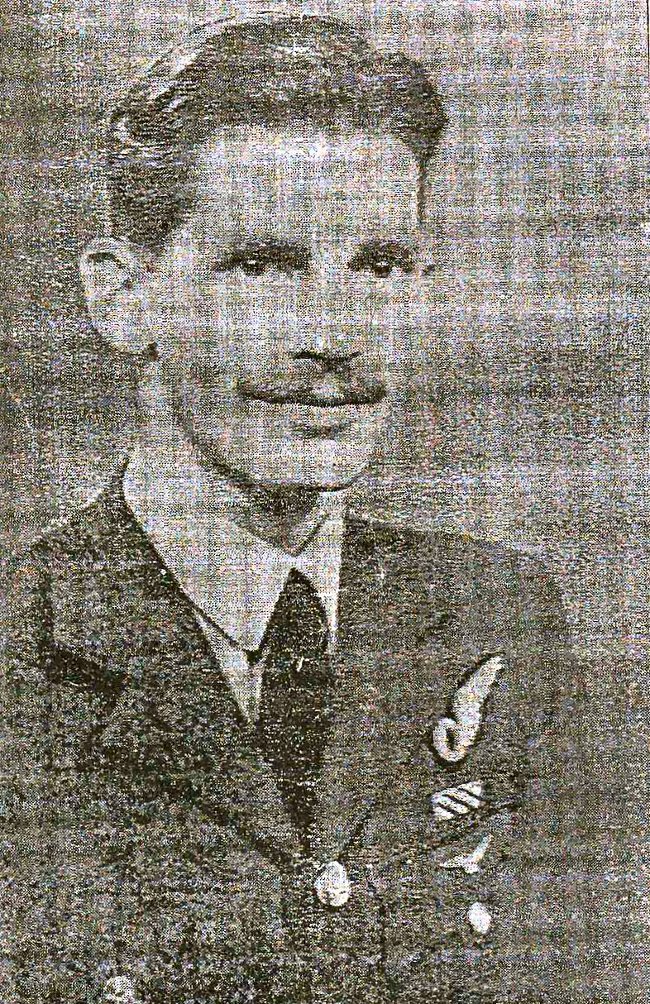

Banffshire Journal, Tuesday, 31st. October 1944: -
AWARD OF D.S.O. - Distinguished Boyndie Airman - It will afford much pleasure in the Boyndie and Banff District, to learn that a gallant local R.A.F. officer, Squadron Leader Harry A. Scott, D.F.C. and Bar, has now been awarded the further decoration of the D.S.O. He is one of the intrepid Pathfinder pilots.
A fine record of distinguished war service in the air, and of well merited promotion is that of Sqdn. Ldr. Scott, who is the elder son of Mr. and Mrs. Scott, of the small farm of Nether Blairmaud, Boyndie, formerly of Thriepland and Whyntie Cottages. He was born at Keilhill and is in his 27th. year.
Making the R.A.F. his career on leaving school, he joined in 1933 and first served his apprenticeship as a fitter and rigger before training for flying service, and at the outbreak of war he was a flight-sergeant. He was among the first to have battle experience in the early days in France, and he has been in the thick of it almost ever since.
Many Exploits - He fought rearguard battles over Belgium at the evacuation from Dunkirk, and recently he has been back there fighting in support of the armies poised for the Battle of Germany. He has fought with Coastal Command as well as Bomber Command and the number of his operational bombing and pathfinding exploits over Germany had long ago reached an impressive total. He has been twice wounded, once when his aircraft caught fire, and the second time in a crash, and in both cases he escaped serious injury.
He gained his commission as Pilot Officer in 1941, and swift promotion followed. As Flt. Lt. he won his D.F.C. in April 1943 and the bar to that decoration about a year ago, and the same year he gained his Pathfinder Badge. Since then he has attained the rank of Squadron
Leader, and now comes the news of the high distinction of the award of the D.S.O. on which the congratulations of many friends in the district will go out to him and his parents at Nether Blairmaud.

__________

From the Press and Journal, Saturday September 22nd 2007:-

NORTH-EAST SQUADRON LEADER ‘USED UP NINE LIVES’
By John Thomson

A north east man who took part in more than 100 wartime flying missions as a navigator and later worked on the development of the modern radar system has died after a short battle with cancer.
Squadron Leader Harry Scott, 89, DSO, DFC and bar, from Portsoy, volunteered to serve with an elite Pathfinder squadron in Bomber Command during World War II. The hazardous job of the Pathfinder crews was to locate and mark targets with flares.
His son, Archie, said yesterday: "He was quite reserved and modest about his wartime exploits, but I think there's no doubt he used up all his nine lives. The dangers of his role were underlined in 1941 when he was the only survivor of an aircraft which crashed on return to Britain. On another occasion, he was injured when an explosion occurred on the ground as an aircraft was being loaded with bombs. He was left deaf by the incident and was invalided out of the RAF in 1948. Mr Scott of Gordon Crescent was born at King Edward near Banff and educated at Portsoy
He joined the RAF in 1933 as an apprentice fitter and rigger before training as a navigator.
On his return to the northeast, Mr Scott worked with a threshing mill construction
firm near Portsoy, and then as a farm mechanic. He then spent 27 years as a mechanic and fireman at Portsoy Motors until he retired in 1982. A widower, he is survived by two sons and two daughters. His funeral takes place at 1.30pm on Monday at the Church of Scotland. Portsoy.
____________

From the Banffshire Journal, Wednesday, September 26, 2007: -

WARTIME HERO EARNED FAME AS A PATHFINDER

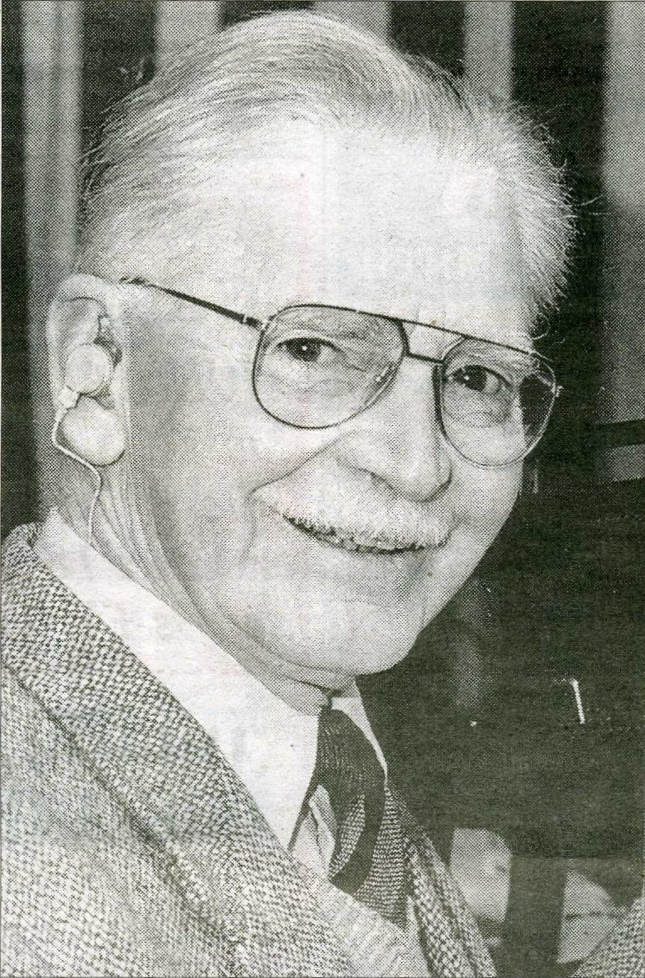

A highly decorated but very modest hero of the Second World War died last week at the age of 89. Harry Scott lived in the Portsoy area his whole life, working as an engineer and mechanic, enjoying a game of bowls and some rifle shooting.
But he was also a wartime RAF Squadron Leader, who flew more than 100 combat missions as a navigator, including many in one of the most important sections of the RAF - the famous 'Pathfinders’ - who led the huge night bombing raids to their targets, often deep inside Nazi Germany. For his bravery he was awarded three medals: the Distinguished Flying Cross (DFC) and bar (i.e. he won it twice); and the Distinguished Service Order (DSO). It was very rare for a navigator to be so honoured.
His citation for his DSO in 1944 stated: "He is an observer of the highest standard, and his brilliant work has been an important factor in the success of many operations. "He has displayed outstanding coolness and courage in the face of the heaviest opposition, and his example has inspired all. His record is outstanding."
Even after the war, he continued to carry out vital duties for the RAF, conducting experiments in airborne radar which took him to North America and the Middle and Far East, and earned him more praise for his abilities and dedication.
It was a far cry from his early life. Born in King Edward, he was the oldest of his family. They moved to farms in the Boyndie area when he was young, and Harry was educated at Portsoy.
At the age of 16, he joined the RAF as an apprentice fitter and rigger, but resisted efforts to become a pilot or gunner, recalls his youngest brother, Charlie: "He was only interested in navigation." At the start of the war, he flew bombing missions, covering the retreat to Dunkirk.
He flew in the Fairey Battle, an aircraft so outclassed by German fighters that his was the only one from his squadron to make it back to Britain as France fell to the Nazis.
He flew combat missions through the whole war, in every sort of bomber: Hampdens, Wellingtons, Ansons, Manchesters, the legendary Lancasters and even in a Flying Fortress.
But it was when he volunteered in 1943 for the dangerous role of pathfinding, flying in the Mosquito bombers of 109 Squadron, that he earned his fame. In the dark, and using a primitive radio beam, he guided his plane to the target, dropping flares as a bomb-marker for the massive bomber groups behind him.
He was once asked by his station commander if his parents were pigeons, because he always found his way home. One of his regular pilots was RAF legend Keith 'Slim' Somerville, later a Group Captain, and also decorated for bravery. At the end of the war, Squadron Leader Scott became an instructor, before the RAF used his abilities to help radar development. In 1948, his wartime injuries caught up with him and he was invalided out of the RAF He had been the only survivor of an aeroplane crash in 1941, and his hearing and sight were damaged in an explosion on the ground when his plane blew up while being loaded with bombs.
He had married Portsoy girl Janet Wright in 1945, and after leaving the service, he became a director of her family's firm, Wright Brothers, from Boyne Mills, who made threshing mills. He then spent some years at Broom Farm as an agricultural engineer, maintaining their dairy equipment, and their milk delivery fleet. In 1955, he joined Bert Masson's new garage in Hill Street, Portsoy Motors, as foreman mechanic, where he spent the last 27 years of his working life.
He was an excellent shot at local rifle clubs, and also took up bowls. He was a founder member of the Portsoy 75 Club, and was later made an honorary member. The club invited him to be their guest of honour at their VE Day commemorative party in 2005, where he cut the cake.
After his wife died three years ago, he lived alone in the house at Gordon Crescent that he had occupied since it was built, until six weeks ago, when he went into hospital suffering from cancer.
He died last Wednesday at the home of his daughter, Patricia, at Mill of Allathan, New Deer. His other daughter, Harriet, lives in Turriff. He is also survived by two sons: Archie, who lives near Reading, and Alasdair, who stays in Portsoy. His funeral took place in Portsoy on Monday.

The Daily Telegraph, Monday October 22 2007 : -

Squadron Leader Harry Scott

Navigator with the Pathfinder Force who became a specialist in the top-secret blind-bombing

SQUADRON LEADER HARRY SCOTT, who has died aged 89, started his RAF career as a teenage aircraft apprentice and, after training as an air observer, became one of a small group of specialist navigators who pioneered the use of the blind-bombing aid "Oboe" with the Pathfinder Force. Scott had already survived two tours on bomber operations when, in October 1942, he joined the newly-formed No 109 Squadron equipped with the fast and highflying Mosquito. Oboe was a ground-controlled, blind-bombing system developed by the Telecommunications Research Establishment and based on the German Knickebein beam bombing system. It required precise navigation and timing for the Mosquito to fly down a narrow radio beam directed towards the target by the ground-based emitter; the aircraft would then drop flares and markers over the target to be used as an aiming point for the main bomber force.
Oboe was so secret that the bomber crews were told only that the markers they were to aim for had been placed by "a new and very accurate method". Scott was one of the five crews that marked Essen on the night of March 5-6 1943, an attack that signalled the start of what was to become known as the Battle of the Ruhr.
Five nights later he returned to Essen in a raid that pinpointed the Krupp factory. Photographic reconnaissance the following day showed that the raid had been very accurate, and a few days later Scott was awarded a DFC — the citation for which referred to his long and successful career in the early days of the war.
As Oboe was developed it became possible to bomb targets deeper into Germany, and Scott marked many targets. As one of the most experienced navigators on the squadron he was regularly entrusted with carrying out the first operation employing new techniques, and in November 1943, he was awarded a Bar to his DFC

In the lead up to D-Day it was essential to limit the casualties amongst the French population, so accurate target-marking was crucial. Scott and his fellow aircrews on No 109 were in great demand. He marked railway yards, gun batteries and radar sites, and after the invasion he marked the V-l flying bomb sites. Late in 1944, by which time Scott had flown more than 80 Oboe operations, he helped develop and test more advanced blind-bombing equipment.
Scott achieved many "firsts" with No 109. On one daylight raid in an
Oboe-equipped Lancaster he led a tight formation of other Lancasters whose instructions were to release their bombs when he dropped his. They were flying above solid cloud and he later commented: "I remember thinking, someone is in for a surprise down below when that lot arrive."
After completing more than 100 bombing operations he was awarded a DSO for his "outstanding coolness and courage in the face of the heaviest opposition".

Harry Alexander Scott was born on New Year's Eve 1917 in Aberdeen. After attending Portsoy School, Banffshire, he joined the RAF in January 1934 as an aircraft apprentice at Halton, where he trained as an engine fitter. On graduation in 1936 he joined No 83 Squadron and soon volunteered to be an air gunner in the squadron's Hind bi-plane bombers.
In April 1939 Scott was accepted for training as an air observer, and on completion of his training at West Freugh, near Stranraer, he joined No 150 Squadron, equipped with the already outdated Fairey Battle light bomber. On the declaration of war the squadron flew to France as part of the Advanced Air Striking Force.
During the opening weeks Scott flew reconnaissance missions and night leaflet raids. When the German advance began on May 10 1940, No 150 attacked enemy columns advancing through Belgium and France. The losses amongst the Battle squadrons were very heavy; on one occasion No 151 lost all five aircraft in a single raid. The Battles were subsequently switched to night attacks.
By mid-June Scott and his crew were the last remaining of those who had flown out to France. With the remnants of the squadron he flew back to England on June 15. He was lucky to have survived - though what bothered him most was the thought of having to confess to his mother that he had lost a pullover she had knitted for him.
In April 1941 Scott joined No 61 Squadron, flying the Hampden for a second tour of operations. Returning from a raid on Cologne on July 31, his Hampden crashed on landing and he was the only survivor. By the time he had recovered from his injuries, the squadron had converted to the Manchester, a bomber that was beset with problems and whose greatest claim to fame was to spawn the Lancaster.
He completed many sorties over Germany, including the first "Thousand Bomber Raid" on Cologne, on May 30 1942. Shortly afterwards he was rested.
After more than two years of continuous operations with No 109 Scott became an instructor on Pathfinder techniques until November 1945, when he was posted to RAF Defford, the airfield used by the Telecommunications Research Establishment, where his unique experience with Oboe was in demand.
He flew trials over the Atlantic evaluating new navigation aids, and in the summer of 1946 flew to the Far East to assess the impact of large electrical storms on the performance of navigation and radio aids. He was awarded a Commendation for his work.
At one point during the war a huge explosion had impaired Scott's hearing, and in January 1948 he was invalided from the RAF. For the next 25 years he worked as a mechanical engineer on farm equipment and later at a motor garage.
Scott was an excellent marksman with the .22 rifle. He competed at Bisley, where he won numerous prizes, and shot in the Small Bore Rifle League in north-east Scotland until his eyesight began to fail. He was also keen on bowls, and for 25 years was a member of his local club, which supported many charities in Aberdeenshire and Banff.
Harry Scott, who died on September 25, married in 1945, Janet Wright, who died in 2004; he is survived by two sons and two daughters.

(Book 5/Harry Scott) Revised 22 November 2026

