History of 23-27 North High St. Portsoy

Researched by Findlay Pirie

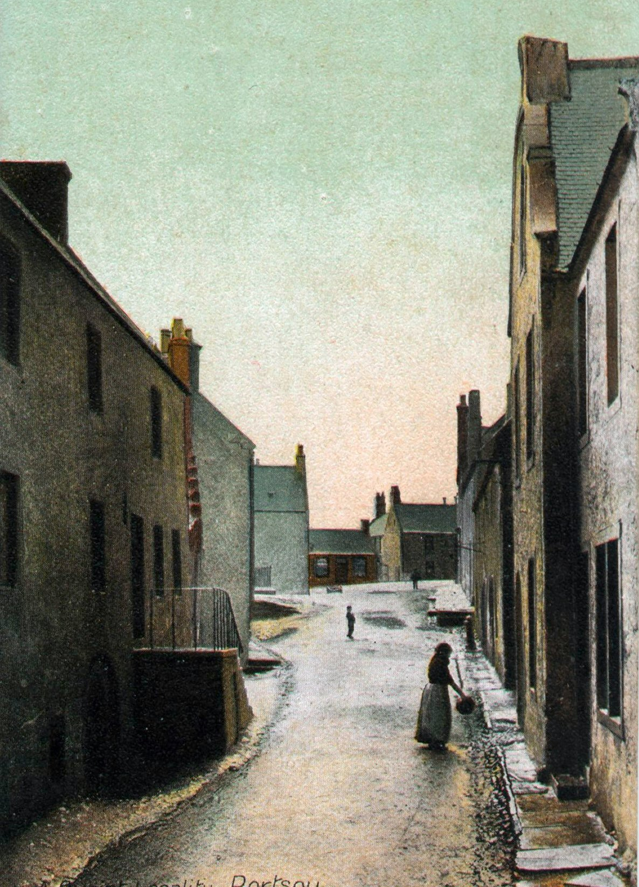
23-27 North High St. is the tall building on the near right.

TITLE DEEDS – 23-27 NORTH HIGH ST PORTSOY

The oldest document amongst the papers is titled “Charter of Confirmation by the Earl of Seafield in favour of William A. Minty” merchant and is dated 9th February 1867 and this document refers to Thomas Mackie, Merchant in London being granted a Charter for the feu in 1762
Whilst Thomas Mackie is shown as being the holder of the feu the document also refers to an Alexander Mackie, Merchant, and I presume that these two were of the same family with one running operations in Portsoy and the other in London. This was quite a normal practice amongst the Portsoy merchants, some even having agents in the Continent.
“Mackie” is quite a common name in the North-east and I feel sure that is where they originated from.

The following inter-office Customs Board letter confirms that there was a Mr. Mackie in situ at Portsoy around that time : -

CE87 1/3
17 February 1750
Upon the 12th January we received an express from the tidesmen at Portsoy acquainting us that the “James & Anne” of that place, Alexander Ferguson master, from Morlain was come into that harbour in ballast. We directed the tidesmen to order in the master here to give an answer of his voyage, which he has never yet done. Since that time we have received the enclosed letter from William Reid, tidesman at Cullen, giving information that the said vessel had run her cargo on that coast and subjoining a list of witnesses proving the same. After perusing this letter we are at a loss to understand it fully or to give your Honours the substance of it. We observe that he says one boat run 5 hogsheads of wine out of this ship and that they were lodged in Mr Mackie's cellar in Portsoy. The witnesses he adduces to prove his information are the fishermen and sailors who were employed, as he says, at the running and how farther evidence is to be depended upon we cannot say ...

Notes : - The above would appear to indicate that Mr. Mackie had got himself involved in the smuggling trade. This is the only reference to the Mackies I have found in my records. - F.Pirie.

Known proprietors of 23 -27 North High Street : -

9th Feb 1762 Thomas Mackie, Merchant in London
Alexander Mackie, Merchant
George Grant, Solicitor
John Farquharson, Painter
1867 William A. Minty Merchant
1879 Adam L. Minty & William A. Minty
1895 Alexander Mills
1919 Mrs. Barbara Pirie & Miss Lily Miller
25 1937 Mrs Barbara Pirie
23 & 27 1937 Mrs. Jane Hogg (Reid)
23 & 27 1938 Mrs. Florence McHattie
25 1955 William J.F. Wilson
23 & 27 1959 Mrs. Margaret Lobban
25 1969 Mrs. Margaret Shearer (Lobban)
23-27 1988 David H. Cox

Charter of Confirmation

By the Earl of SeafieldIn favour of William Minty

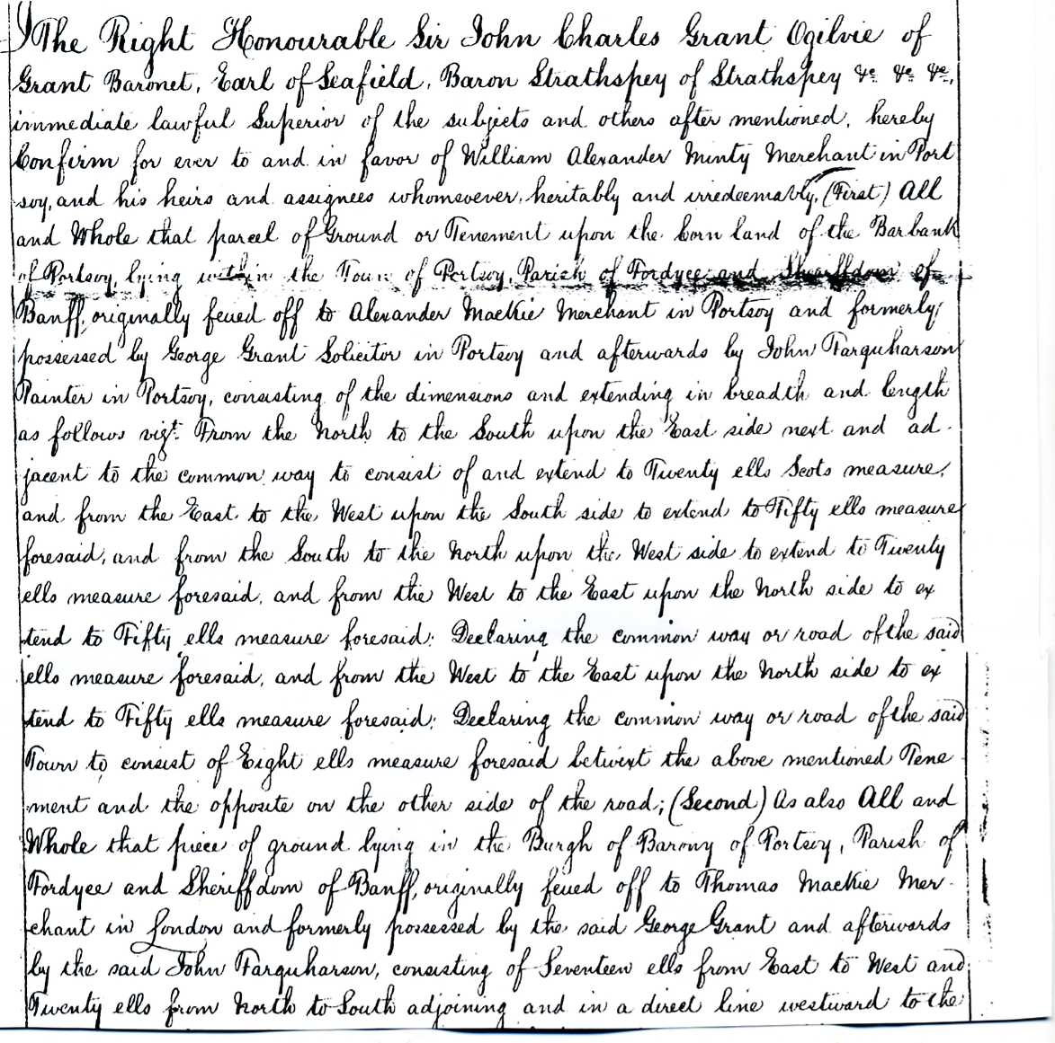

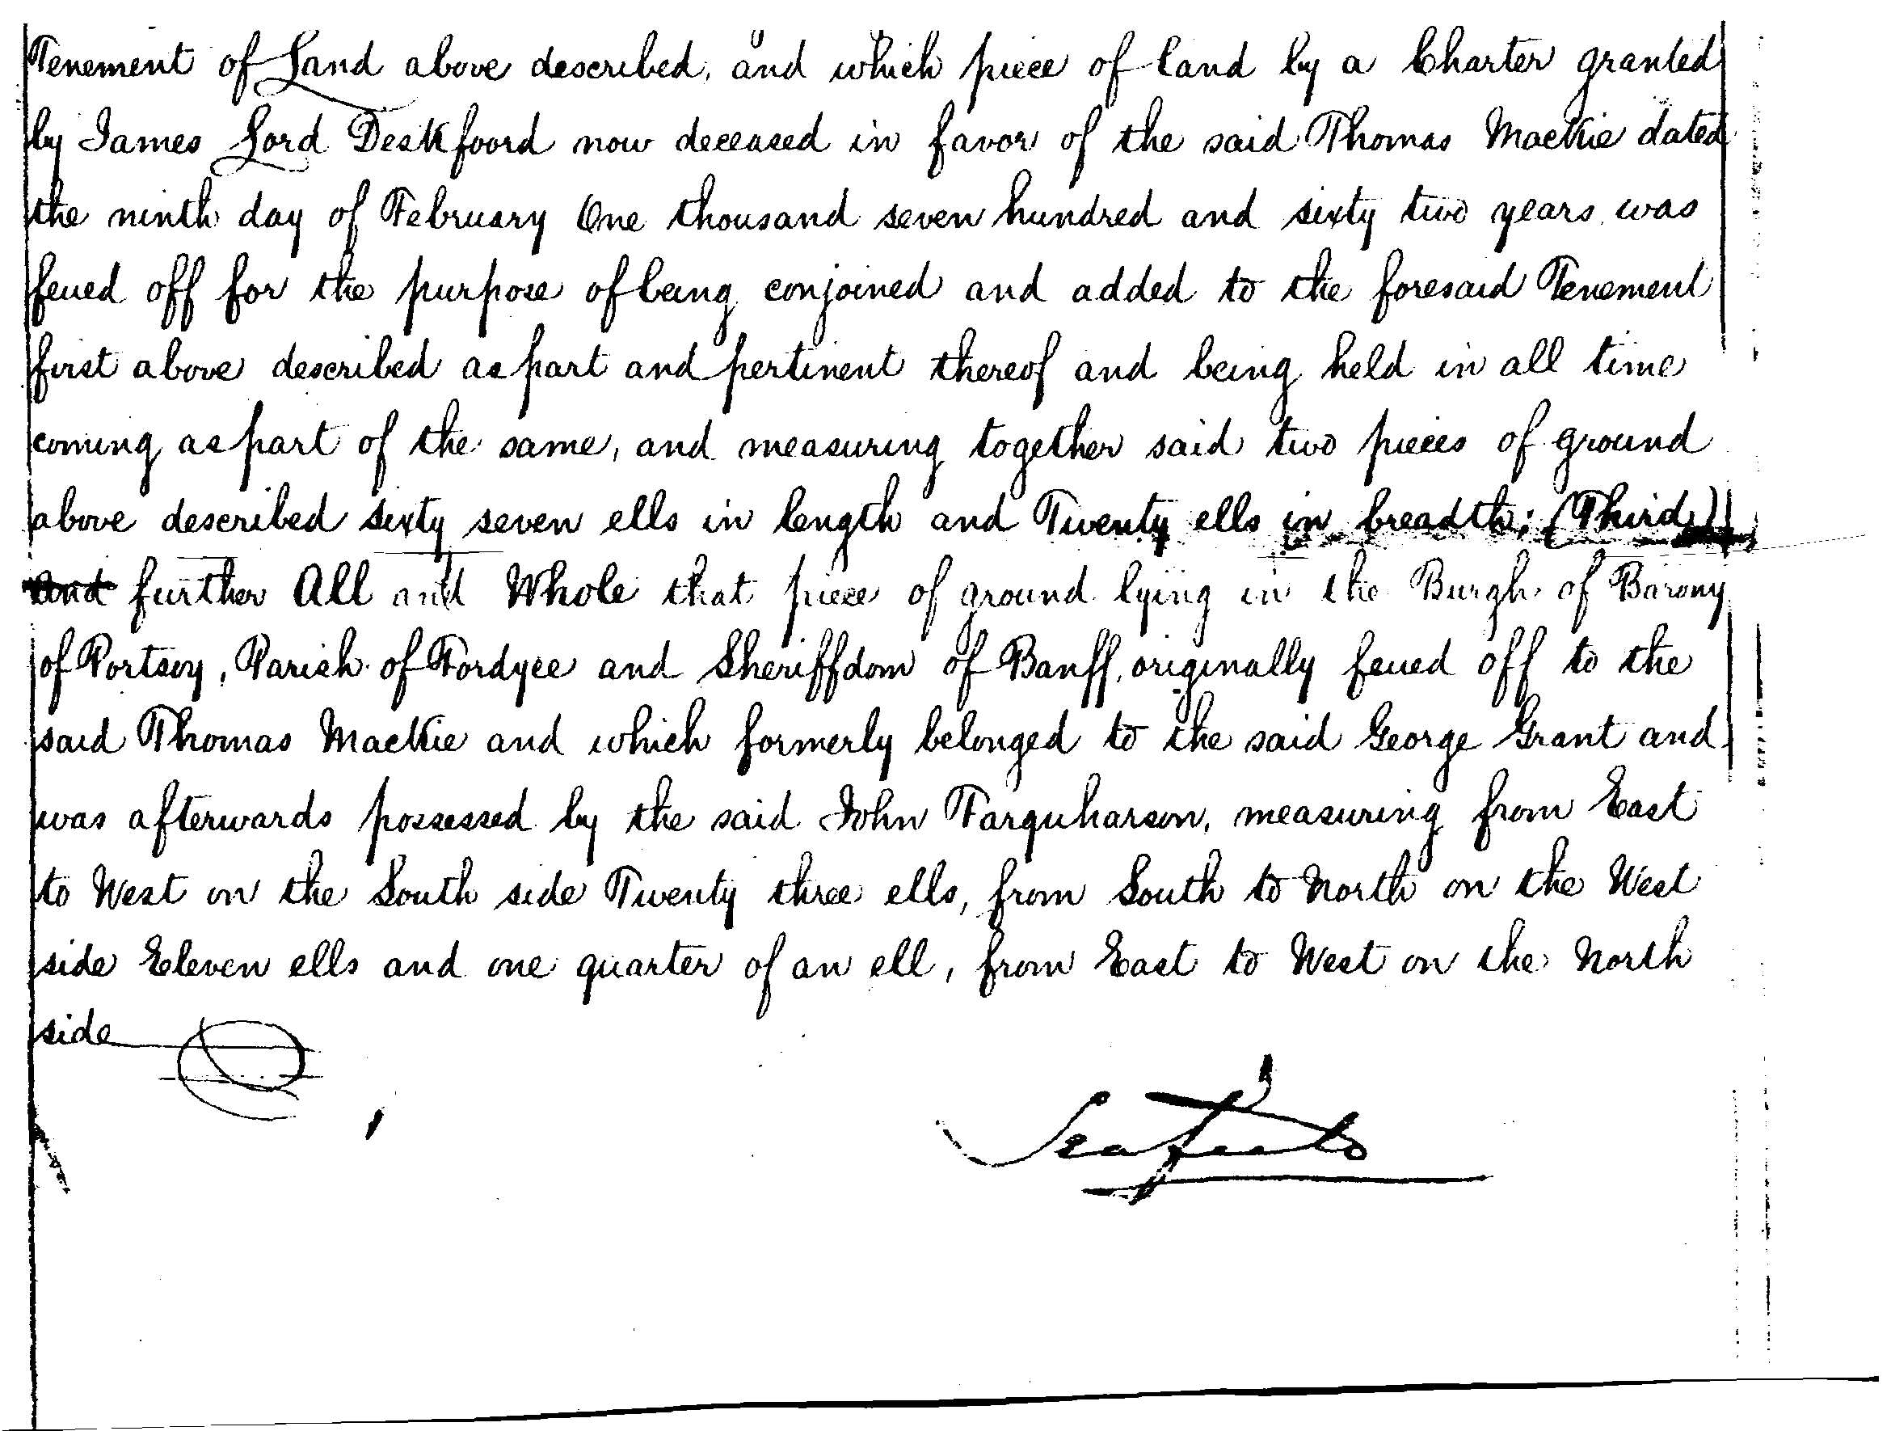

____________
William Minty 1772 – 1835
Married Elspet Longmor and had 12 children
Purchased the property 23-27 North High Street, Portsoy in 1867
Carried on an extensive and very profitable business in the Square selling clothes and trading as a silk mercer and this was without getting himself involved in the smuggling trade. Also dealt in teas wines and spirits and had financial interests in the shipping trade of Portsoy
It is recorded that on the 28th March 1832, David Stevenson, mason (preses), John Fraser, weaver (treasurer) and Alexander Watson, merchant, (clerk) of the Society of the St. Stephen’s Lodge of Freemasons along with a committee of William Clark, James Scott, William McLeod, Alexander Burgess, John Brebner and Alexander Lawrence, sold the subjects belonging to them in the Square to Mr. William Minty, merchant in Portsoy, for £241.
Dr. George Greig. the local Doctor and historian wrote in his 1843 Manuscript : -
“About midway between the Harbour and the upper part of the town is the Square a wide open space where streets intersect each other and in which are some of the best houses in the town. The North West side of it was long disfigured by a row of small mud walled ruinous houses which formed a most disagreeable contrast with the other buildings and completely hid some excellent houses situated to the rear of them. Fortunately in 1832 these became the property of the late Mr William Minty a most worthy and public spirited individual who removed the old houses and erected a neat cottage. Soon afterwards he purchased the adjoining property belonging to St Stephen's Mason Lodge and the whole underwent a complete repair which has very much improved the appearance of that side of the Square: His

design has been fully carried out and completed by his son Mr A L Minty the present proprietor.”

Adam Longmore Minty 1808 -1883 Alexander Minty 1819 - 1897
Carried on the business after their father died.

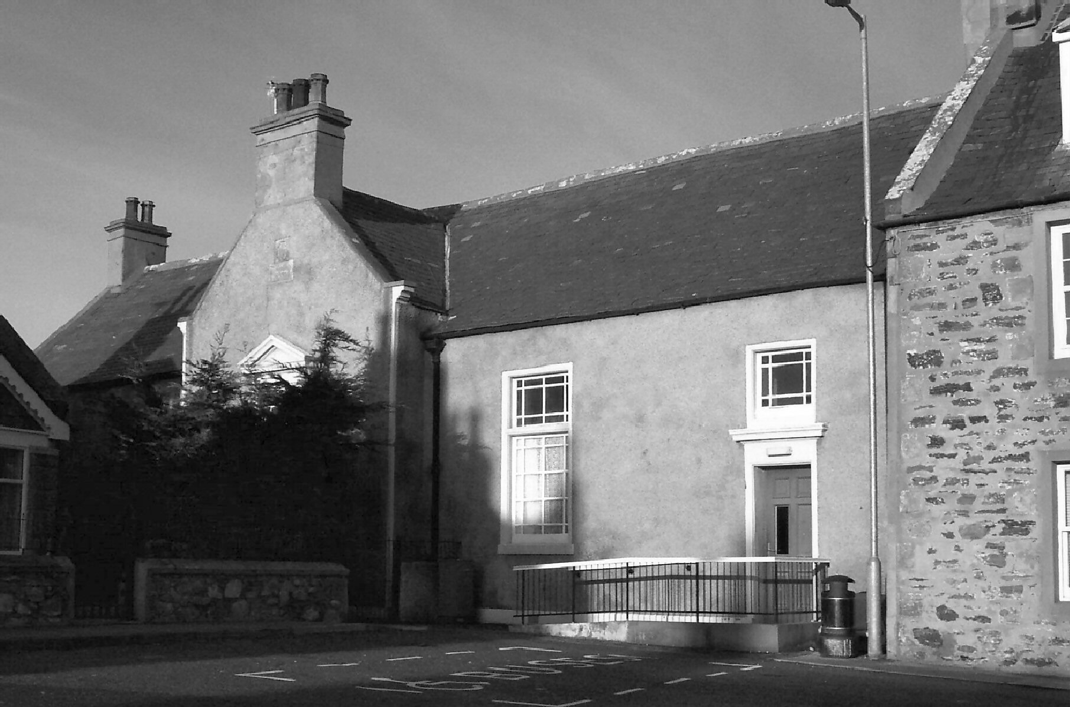

Minty’s Hall in the Square, Portsoy

(/Book2/23-27 N. High St) Revised : - 24 November 2026

