History of Portsoy

THE CHURCHES AND RELIGIONS

Researched by Findlay Pirie

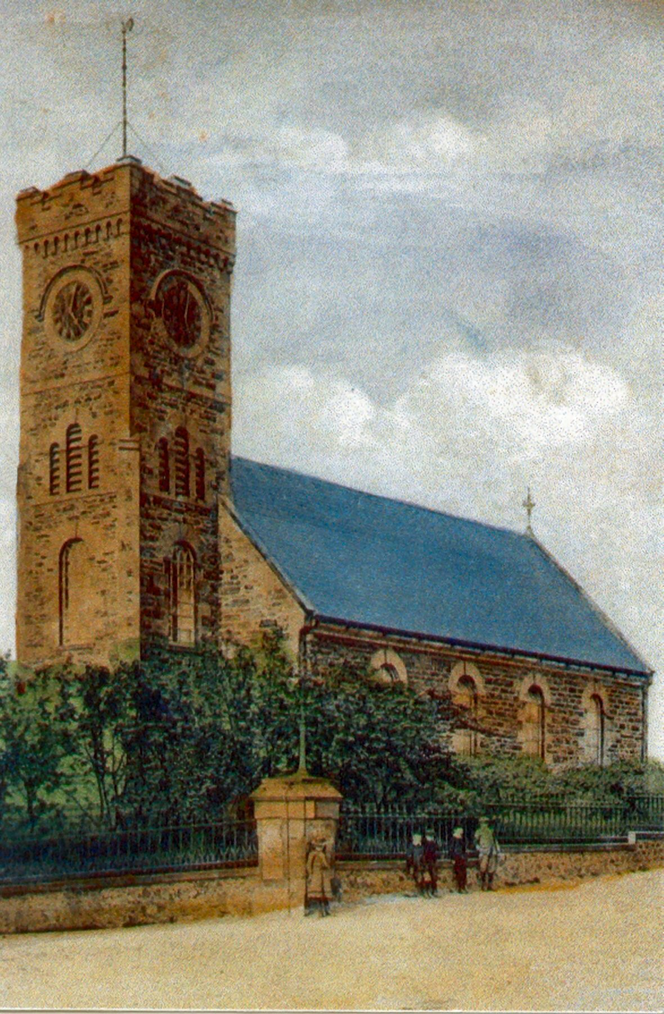
The “Auld Kirk” Seafield Street, Portsoy. Built 1815-1816

THE CHURCHES AND RELIGIONS.

From the booklet "Banffshire Churches" by Donald Findlay: -
CHRISTIANITY IN THE MIDDLE AGES - Christianity came to Scotland in the closing decades of the Roman occupation of Britain. Ninian settled in Whithorn in Galloway in the early fifth century and from there sent out missionaries to the southern Picts, and in 565 Columba arrived from Ireland and founded his monastery in Iona. He too sent out missionaries northwards and eastwards into Scotland. It is not clear whether the blue-painted Picts of Banffshire first heard the message of the Gospel from Ninian's men or from those of Columba, but the former seems more likely.
That the early Christians took over the ancient Pictish sites is clear from the stones carved with mysterious Pictish symbols which survive at several churches, such as the well-known group of four at Inveravon, found under the old church when it was demolished in 1806, or the single stone at Artendol, now built into the wall of Arndilly House, or the two stones found at Mortlach. The quality of the water, which was to bring fame to Banffshire from a later industry, was a powerful asset for the Celtic missionaries to deploy in the conversion of the people to the new religion ; for water, especially Banffshire water, could cleanse them outwardly from disease and inwardly by baptism. Even today there are springs in almost every parish of the county named after the Celtic saints associated with them:- St. Drostan at Aberlour (although now covered by a distillery warehouse), St. Marnan at Marnoch, St. Maelrubha (now contracted to St Rufus) at Keith, and St. Colm at Portsoy. Indeed at Portsoy can be seen the earliest 'church building' to survive in the county. It has been much rebuilt certainly, but the stone beehive over St Colm's well in the old churchyard is typical of a very old building method, and inside it the little well still trickles.

From “A History of Portsoy Churches” published in 2000 by Portsoy Parish Church :-
THE REFORMATION IN SCOTLAND - The Reformation in Scotland is said to
have begun in 1560 when the Scots Parliament repudiated the authority of the Pope. Until 1690, the Scottish Church was uncertain as to whether it would have bishops or not. Initially the dioceses were administered by “Superintendents.” In 1672 the Convention of Leith restored the title of “Bishop” and in 1592 Andrew Melville introduced the Presbyterian system to Church Government.
In 1610 James VI and I reintroduced Bishops, and his son Charles 1 tried to enforce a Book of Common Prayer and in particular a universal order for celebrating Holy Communion,
a service popularly known as “Lauds Liturgy” or the Scottish Communion Office of 1637. This provoked the outburst of Jenny Geddes in St. Giles Cathedral in Edinburgh and the signing of the National Covenant in 1638. The Covenanters reimposed the Presbyterian system of Church government. The restoration of the Monarchy in 1661 saw the re-establishment of Bishops and the savage persecution of the Covenanters. James VII and II was deposed in 1689 and the refusal of the Scottish Bishops to swear allegiance to William of Orange resulted in the expulsion of the Bishops and those Clergy who supported the Bishops and the House of Stuart (the “Episcopalians”).

The Episcopalian Clergy were put out of their Churches and Manses and set up chapels or “Non Juring Meeting Houses” in opposition to the now Presbyterian National Church. The position in Portsoy as in much of the North East is unclear. The account of the Parish in the Third Statistical Account of Scotland (1690) indicates that the Parish Minister of Fordyce was deprived of his charge by order of the Privy Council. The list of Ministers at Fordyce provided in the Second Statistical Account (1844) indicates that the Rev. Alexander Gallie came to Fordyce from Deskford in 1684 and died in office in 1715. It may have been that the orders of the Privy Council were not enforced until after the 1715 Jacobite Rising. Certainly Mr. Gallie was replaced by a minister acceptable to the Presbytery. Those who remained loyal to the Bishop and Episcopal cause were separated from the Parish Church and set up a Non Juring Meeting House outside the Burgh on land owned by the Dunbars of Durn who were sympathetic to the Episcopalian cause.

Banffshire Journal, Tuesday, March 23rd. 1869 :-
ERECTION OF PORTSOY INTO A PARISH QUOAD SACRA The Church of Scotland is putting forth considerable vigour in this quarter. We have noticed the arrangements for the erection of Ord and Wells-of- Ythan into parishes quoad sacra; and we now have to mention that on the 15th. inst. the ease of disjunction and erection of the district of Portsoy into a parish quoad sacra was initiated in the Court of Tiends. As there is no manse, a sum of £3000, or what will yield £120 annually, is required for the endowment. Some time ago the Endowment Committee voted for Portsoy £2000, or an annual payment of £80. The Right Hon. the Earl of Seafield has agreed to make his annual grant of £20 permanent, which is equal to a subscription of £500, besides generously cancelling a heavy debt which was on the Church. The remaining £500 of endowment, with from £100 to £200 for expenses and maintenance of fabric etc., are being raised by local subscriptions, aided to the extent of £250 by the executors of the late Miss Strachan of Cortes.
The new parish is estimated to contain a population of 2200, and there is a congregation of 450.

Banffshire Reporter, Wednesday August 26th 1903
A BANFFSHIRE WATERING PLACE - We are now on the main thoroughfare from east to west, where ample provision is made for the worship of God in a quoad sacra Established Church, two United Free churches, an Episcopalian, and, pleasantly situated at the east end of the town, a neat chapel for those who worship according to the Roman Catholic faith. The time was when there was also an Independent Chapel ; the site of which is now occupied as a substantial dwelling house dignified by the title of Chapel House. A remnant of the faithful adherents still remains to cherish the blissful memories of the past and the great and good work done by that sturdy independent John Murker - a name which is a household word all along this coast.

Banffshire Journal, Tuesday, January 2nd. 1940 :-
PORTSOY MEMORIES - The burgh was well supplied with churches, in the late 'seventies no fewer than six for a population of two thousand five hundred. Well might a stranger assume that he had discovered a religious people. That would perhaps be a ticklish job to decide, but comparison is odious, and had better be left to those concerned. The stranger, however, without being inquisitive, might well ask why three Presbyterian churches when one might accommodate them all ? Their faith and doctrine being similar, it was a dissipation of force. But now all has changed. All have returned to the National Zion. The Episcopalian and Roman Catholic still keep their flags flying, but the Church representing the Congregational persuasion has disappeared
The Roman Catholic Church had as incumbent a very genial, much and generally beloved old gentleman. He was transferred somewhere about the late 'seventies. He dearly loved his pinch of snuff. It is recorded that his first attempt at sermonising was from the top of a herring barrel. The story goes that the top fell in, no doubt putting an end to the attempt, but as it turned out, only for a time.

Banffshire Reporter, Saturday July 5th 1888 :-
CHRISTIAN INSTITUTE - The Portsoy Christian Institute was opened on Wednesday last (July 2nd.). William Ferguson, Esq., of Kinmundy performed the opening ceremony, delivering on the occasion an address full of sound advice to young men. Sheriff Scott-Moncrieff and Provost Williamson Banff also delivered addresses. (Extract from a lengthy report).

THE ESTABLISHED CHURCH, PORTSOY.
(THE AUL’ KIRK)

1741 - PLACE OF WORSHIP OPENED AT PORTSOY.
From a manuscript of 1843 - published in the Banffshire Journal September 20th. 1938 :-
Until 1741 the inhabitants of Portsoy belonging to the Established Church attended public worship at the Parish Church of Fordyce, there being no place of worship of any description in the town.
This was felt to be a serious inconvenience especially in winter, the distance being two miles and the roads far from good. Accordingly in the year of 1741 it was made a preaching station, the Committee for distributing the Royal Bounty nominating the Clergyman and paying him £20 per annum of stipend. The Earl of Findlater, however, offered to relieve the committee of the burden of the stipend, providing he was allowed to nominate the incumbent. In this they agreed and the patronage has ever since remained in the family. The first Presbyterian place of worship in the town therefore was opened in the above year. It was situated in the Back Street (later designated part of Church St ) nearly opposite to the Burnside Distillery.

1746 - ESTABLISHED CHURCH BUILDS CHURCH AT CORNER OF CHURCH ST. & INSTITUTE ST.

From a Portsoy manuscript of 1843 by Dr. George Greig:-
In 1746 a new church was erected at the top of Church Road on the site of the present Society's School (now the YMCA Hall) which was a very neat building with galleries on the outside and surmounted by a belfry on the west gable.
The bell was cast on purpose in Holland as appears by the following inscription 'For the Presbyterian Church of Portsoy. John Spricht Rotterdam fecit 1746. ' The bell is still used by the Society's School.

From the Banffshire Reporter, June 8th. 1904:-
THE "RED" OR "REID KIRK," PORTSOY. - In Dr. Small's Small's "History of U.P. Congregations," just published, we find the following anent the "Red" or "Reid Kirk," Portsoy, which was situated in Schoolhendry:-
"In the beginning of 1782 Mr. Cowie (Anti-burgher Minister) of Huntly was dealt with by his Presbytery for going to hear a Relief Minister one Sabbath afternoon. A petition was brought before Glasgow Relief Presbytery in August of that year from "the forming Congregation of Huntly and Portsoy." In September 1784 it was reported to the Anti-burgher Synod that the Rev. Lawrence Reid, who had left Pathstruie under a cloud, was taking charge of what is called the Relief Congregation in Portsoy, and in the following year they deposed him for deserting his profession. In or about 1792 he removed to Findhorn, where he preached to a Quasi-Relief Congregation for a course of years. In 1793 he applied for admission to the Relief Synod, but was rejected. His death is given in the "Caledonian Mercury" for 10th. August, 1808, as "Minister of the Relief Congregation at Findhorn".
As for Portsoy, some of the people there about the time of Mr. Reid's removal applied through Grange Session to the Anti-burgher Presbytery of Aberdeen for supply of sermon, which was granted them apparently about once a month. Then in 1793 Mr. Primrose (Minister of Whitehill, Grange) signified at one of their meetings that an application had been made to the session from Portsoy to have a part of his labours. Next year an arrangement was come to, that he should preach there every third Sabbath, and three commissioners,
representing seceders and others in that place, engaged to pay one-third of his stipend, and they also agreed "that he and his horse be maintained when there," the places being eight or nine miles apart.
This system went on for eight years, though not without difficulty, owing to the people of Portsoy falling into arrears with their portion of the stipend, which was only £40 in all. The winding up came in July 1802, when a complaint was brought before Grange Session that four members of the congregation residing in Portsoy had in a clandestine way sold the church there. It appears from the old title deeds that this transaction took place on 16th. February 1802, and that the property was disposed of for £60. It passed at this time into the hands of the Established Church ; and when superseded in 1815 by another church, it was turned by the minister into a barn. Such was the fate of the "Red" or "Reid Kirk" at Portsoy in the last stage of its existence."
We may add that the bell on the Portsoy Public School is the bell of the said Kirk.

Statistical Account of Scotland 1799 – 1799 :-
There is a minister of the Established Church at Fordyce, and a preacher at Portsoy, presented by the present Lord Findlater’s grandfather with L.20 yearly ; likewise a relief one, occasionally a Nonjuror Episcopalian minister, and a popish Priest. The great body of the people are Presbyterians of the Established Church ; There are a few Seceders ; A considerable number of Episcopalians ; A Few Papists.

ESTABLISHED CHURCH IN CHURCH STREET ABANDONED.
From a Portsoy manuscript of 1843 by Dr. George Greig:-
The walls of this Church constructed with clay little more than half a century ago had become insufficient, and the increasing number of hearers made more ample accommodation necessary. Accordingly in 1804 it was finally abandoned and a large barn-looking edifice situated in Skulhendry Street, that had been erected by a Congregation of dissenters, was then hired.

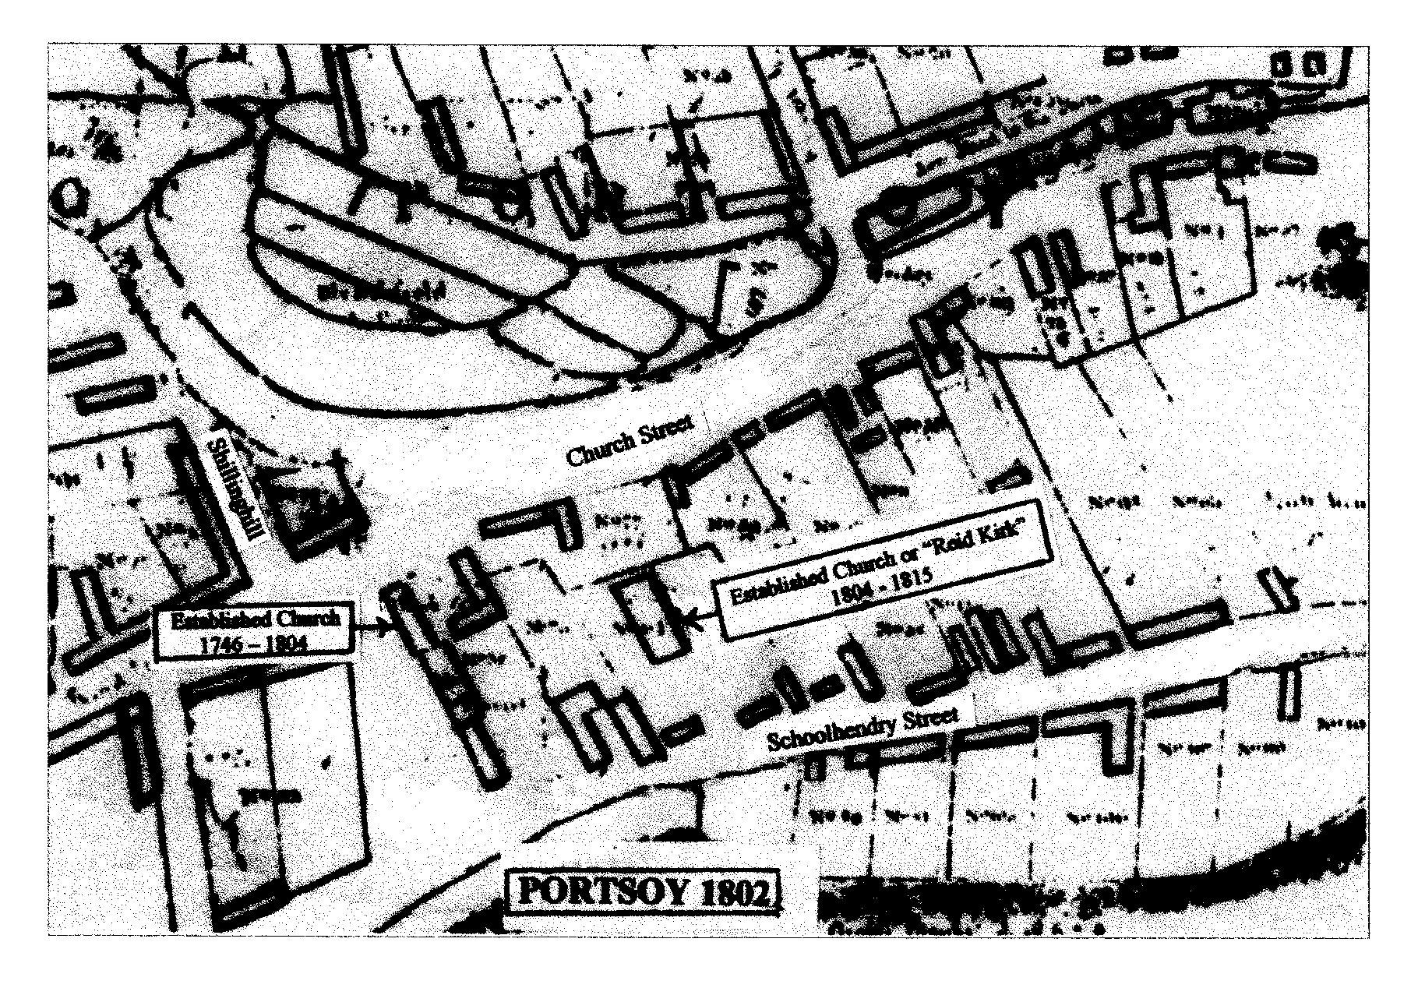

Location of the Reid Kirk

1815 ESTABLISHED CHURCH - FOUNDATION STONE OF NEW CHURCH LAID.
From the Portsoy Manuscript of 1843 by Dr. George Greig:-
The building in Skulhendry Street hired in 1804 being inconveniently small, was altogether most uncomfortable. The walls were destitute of plaster and being concealed the wretched state of the roof proved no protection from the fury of the elements. In short, the miserable state of Portsoy kirk became quite proverbial while from its having a tiled roof and the street it stood in, received the name of the "Red Kirk of Skulhendry".
To these inconveniences the people submitted for twelve years but a better order of things soon took place. By the unwearied exertion of the incumbent, the Rev. Daniel Cruickshank, the funds for the erection of the present church were raised and the foundation laid in the summer of 1815.

1816 THE ESTABLISHED CHURCH (The "Aul" Kirk) IN SEAFIELD STREET COMPLETED -
From the Portsoy Manuscript of 1843 by Dr. George Greig :-
It was opened for public worship by Mr. Cruickshank in 1816:- The contractors were :- mason work, Mr. William Ritchie ; carpenter work, Mr. Selam Wilson ; slater work, Mr. George Scott ; plaster work, Mr. William Stephen. It is a neat but plain edifice calculated to accommodate 700 sitters and has a belfry on the west end but still labours under the inconvenience of being unenclosed and the ground about is a thoroughfare to the public. It is beautifully lighted with gas for the evening service during the winter and has long been remarkable for the excellence of its choir. It is also chiefly indebted to Mr. Cruickshank, who spared no pains in procuring good teachers to instruct the young members of his congregation in psalmody and his successors have also followed his example.
The stipend is paid by seat rents and an annual allowance of £40 from the Earl of Seafield. The payment of seat rents, however, even though they be comparatively low, is felt to bear heavily on the labouring classes.
The following is a list of the Presbyterian ministers of this time since its first erection into a preaching station in 1741:-
Mr. Robert Yule removed to Kirkwall.
Mr. James Ogilvie removed to Ordiquhill.
Mr. Thomas Mitchell.
Mr. Robert Ogilvie removed to Ordiquhill.
Mr. Burnet removed to Footdee, Aberdeen.
Mr. Thomas Steel removed to Dort in Holland.
Mr. Walter Chalmers removed to Deskford.
Mr. Abercromby removed to Banff.
Mr. James Kelly removed to Leochel Cushnie.
Mr. William Grant removed to Inveraven.
Mr. Daniel Cruickshank. Died Nov. 1828 -the first Minister to die in charge

Mr. Alexander Reid. Joined the Free Church in June 1843.
Mr. Peter Murray, admitted Jany 25 1844.

When the United Free Church of Scotland and the Established Church of Scotland united to form the Church of Scotland in 1929 it became known as the "East Church of Portsoy"

Aberdeen Journal, Wednesday March 24th. 1819 :-
FIRE AT PORTSOY - At Portsoy on Monday the 15th. curt. and about noon, a stack of hay, along with a stack of corn and fodder, belonging to the Rev. Mr. Cruickshank was accidentally (as is supposed) set on fire from an adjoining co-operage. Fortunately owing to a mild day and the ready exertions of the inhabitants, the fire was confined to the spot where it originated; otherwise a neighbouring stack-yard and a range of thatched houses northwards on each side of the street must have become a prey to the flames. Quarritur - Ought not coopers be prohibited from framing their casks by fire in the open in streets and lanes (to the great danger of lives and property, especially in the neighbourhood of thatched houses) and compelled to use such fires within their workshops ; otherwise they and their employers will become liable for damages ?

Banffshire Journal, Tuesday, July 13th., 1858 :-
NATIVE MINISTERS PREACH - The Rev. Mr. Saunders preached again on the forenoon of Sabbath last, in the Established Church, and the Rev. James Allan, presentee to Grange, officiated in the evening. At the latter diet there was a very full attendance, and the rev. gentleman preached a very able sermon from Malachi iii and 2nd. verse, last clause, and was listened to with most marked attention throughout. It is seldom that a town like Portsoy can produce two such popular preachers as the above named parties, and although we are told that "a prophet has no honour in his own country" it is gratifying to observe that a visit from either of them to their native place is hailed with great pleasure by people belonging to all denominations.

Banffshire Journal, Tuesday, February 12th 1867:-
DEATH OF THE REV. PETER MURRAY - We regret to see in our obituary today an intimation of the death of the Rev. Peter Murray, for many years minister in the Established Church of Scotland. Mr. Murray has not been well for some time, and recently, accompanied by his wife, he proceeded to England, and at St. Leonards on the Sea his death took place on the 4th. curt. Mr. Murray was a native of Elgin, and was for some time schoolmaster of New Spynie. At the Disruption, he was presented by the Earl of Seafield to the Church of Portsoy, of which he has ever since been the pastor. Of a kindly disposition, Mr. Murray, so long as he possessed the means, generously assisted with money, advice, and personal influence every one in his congregation whose necessities came under his notice. He laboured in his charge under many discouragements ; but still kept on in the performance of his duties till failing health compelled him to seek rest and change of air ; and the news of his death shows that the rest and the repose came too late. During Mr. Murray's absence, the pulpit at Portsoy has been supplied by the Rev. Mr. Gibson, whose ministrations have, we hear, proved most acceptable. We trust that an effort will be made to place this charge on a more satisfactory footing. Means should be used to take advantage of the Endowment Fund, and Portsoy should be constituted a quoad sacra parish. We feel assured that the matter has only to be taken up by the Presbytery and the congregation in a proper spirit, to ensure that, with the co-operation of the Earl of Seafield, this most desirable object be attained.

Banffshire Journal, Tuesday, June 25th. 1867 :-
PORTSOY - ESTABLISHED CHURCH - The Rev. Mr. Gibson, who has been officiating in the Established Church here, for some time, has received from the Earl of Seafield, the presentation to the Church. The services of Mr. Gibson during his connection with the Church, have been characterised by great zeal and ability, and have been very acceptable to the people, so that the congregation which formerly had, through unfortunate disagreements and misunderstandings, been very much broken up and dispersed, have again come together, and are acting cordially and unanimously with one another. The appointment of such a man as. Mr. Gibson cannot fail to have a beneficial effect upon the district, and we feel sure that it has the fervent wish of many that the connection so auspiciously commenced may be a long and happy one. The Rev. Mr. McVicar, Ordiquhill, preached on Sabbath by appointment of the Presbytery and intimated the presentation to the congregation.

1876 CLOCK TOWER ERECTED - The clock tower at the old Parish Church was added. The clock and chimes, however, donated by Mr. Fleetwood and P. Wilson were not installed without some controversy.

Banffshire Reporter, Friday, July 14th, 1876 :-
OUR TOWN CLOCK - This new acquaintance, which for some days past has undoubtedly been the observed of all observers, began, in the most quiet and unostentatious manner, to warn us of the ceaseless flight of time, on the evening of Wednesday last (July 12th), and has continued to do so with commendable regularity, but did so in mute silence until yesterday (July 13th.), when not only the hours, but also the half-hours and quarters were rung out by the second and third bells, the hours being struck on the large one, which has a deep and musical sound, and forms a pleasant contrast with the sound of any of the old bells of the town, which still from time to time let their less harmonious voices be heard.
Though the work of erection may not be completed, and though the interior of the tower is still in a very unfinished state, the clock is now fully serving all the ends for which it has been erected, and while we write, having first denoted that the last quarter of the hour was finished, by striking "ting dong" four times, it has rung out the hour of 9.0 pm. Not having had leisure to see it since its erection, we must forbear further notice of it in the meantime. It will at least be ready to "strike the hour for opening the bazaar" and on that day will doubtless let the musical powers of its chimes be fully heard.

Note:- A unique feature of the clock is that the north-east face (looking towards the sea), bears two elevens. The workman who fixed the Roman numerals erred, in that he placed the number nine as XI instead of IX.

Banffshire Reporter, Wednesday, October 13th 1876:-

LETTER TO THE EDITOR.

Dear Sir,
I was somewhat surprised to find the Chimes of the Town Clock made use of as a substitute for a Bell - a purpose for which they are neither adapted nor made for.
The Clock and the Chimes, as you are aware, was a gift to the town - the former to indicate the hour, and the latter to chime the quarters, and when used exclusively, as originally intended, the harmony of the tones will be increased, and together the Clock, with care, will last for ages.
I have addressed you on the subject in the absence of my friend, Mr. Moir, as I believe when publicity is given to my wishes, the objectionable use of the Chimes will be discontinued. Will you kindly, therefore, give this letter a place in your next “Reporter” and oblige.
Dear Sir, Yours very truly,
Fleetwood Pellew Wilson.
Thomas Anderson, Esq.,
“Banffshire Reporter” Office,
Portsoy.

(Note:- Mr. Fleetwood P. Wilson was subsequently entertained by the inhabitants of Portsoy to a complimentary banquet, in recognition of the handsome gift of a clock and chimes to his native town. At the banquet he took the opportunity to raise further complaints about the installation of the clock.

Banffshire Reporter, Wednesday, October 13th. 1876 :-
BANQUET TO MR. FLEETWOOD P. WILSON - Extract from Speech by Mr. Fleetwood P. Wilson - I come to another most important point. I visited the tower today and went to see the clock, and I am perfectly certain that Mr. Moir is not aware it is not in a suitable place. The clock, if it is not attended to, will not keep time, and will be completely ruined. What is meant to last for ages will not last for years. The place is open entirely to the air ; it is not enclosed in the room it is in ; it is only in stone walls instead of being lathed and plastered, or at all events fenced with wood. Mr. Mortimer, who was with me, told me it is not a fit place for the clock to be in. There had been a slight mistake in the tower. That is a matter that does not concern me in the least, except in one point. The clock is meant to go for eight days, and it has not room for the weight, and has to be wound every six days instead of eight. Had I known the tower was in the state it is in, I should certainly not have allowed the clock to be sent here.
I am certain now that steps will be taken, and I am sure Mr. Moir will see to it that the place is made a habitable place or I would say a proper place for the instrument. I would suggest that the Chairman should call a meeting of the inhabitants of the place, and I would then, by document suitable, make over the clock to the town, and that document should be preserved and perpetuated, and when they were all gone, and perhaps their children’s children, it would remain and he would not, and still he would say, as a memento to the donor, and also it would reflect credit on the town itself. (cheers)

From the book “In Leisure Hours” Printed privately in 1946 by John Cumming, M.D. F.R.C.S.E. F.R.C.S.P.
THE CLOCK AND CLOCK TOWER.

Sunday was indeed a day of rest. An onlooker would have been pardoned had he expressed the view that the populace in general was under the power of a strong sedative. It needed three reminders from John Murphy operating the chimes in the clock tower before any stirring could be observed. He always did his job well, whether as forester on the Seafield estates or as minister's man at the Auld Kirk. Yes, the town could boast of chimes and round them hangs a tale. A prominent native re-visiting the scenes of his youth was approached by a well-known gentleman, -an unappointed but none the less recognised leader in the town, and his persuasive words unlocked the good man's purse sufficiently for the purchase of a clock with chimes.
But this four-faced timekeeper had to be housed, and there was no available building suitable for it. A very small barrier this to resolute and scheming women. An admirable site, central and elevated, faced them; willing hands and diplomatic brains worked hard, and in no time a marquee appeared, stocked with attractive and saleable goods which, with the persuasive begging powers of the genial Auld Kirk minister, accumulated a sum sufficient not only to build a tower, but also to remodel the interior of the old quoad sacra kirk. Upon this tower may be seen inscribed the name of the donor, Fleetwood P. Wilson.

Banffshire Reporter, April 24th, 1880:-
ESTABLISHED CHURCH OF PORTSOY - The above place of worship, which is so soon to undergo a complete renovation, at least so far as regards its interior, was built soon after the beginning of the present century, as a Chapel of Ease for Fordyce, and though of smaller dimensions, in point of design, it is almost an exact pattern of the parish church. The funds for its erection - bazaars as a means of building churches being unknown in those days - were said to have been to a large extent raised through the personal exertions of the Rev. Donald Cruickshank, then the incumbent of the Presbyterian Church in Portsoy, and who also built, as a manse for himself , the house at Burnside, now occupied by Mrs. Greig.
Mr. Cruickshank, who lived and died a bachelor, was regarded as somewhat eccentric. Parson as he was, there were occasions on which he did not hesitate to use expressions hardly fit for ears polite. It was said of him, but few would be willing to vouch for the fact, that upon one occasion he had gone to officiate for a brother clergyman, and did not discover until he was in want of it, in the pulpit, that he had forgotten his sermon. He is said, however, to have been equal to the occasion, as he gave out the 119th. Psalm, and sat down to watch the result, and, as the tale runs , when the congregation had sung themselves hoarse, he rose and after prayer, pronounced the benediction, adding, "Noo, noo, sirs. I forgot my bit paper, but that may sair ye for a day." On one occasion he was in Morayshire, of which county he was a native, on the outlook for a better living, and having been caught in a heavy shower, he said to the boy who was driving him (the late Joseph Stevenson) - "Hech, laddie. I mayna get the kirk, but I hae at least gat ma share o' the steepin' !" He must have been of economic habits, as although his income must have been very small, he left a considerable amount of money.
But it is more with the Church itself we have to do at present. It occupies a very prominent and excellent site, and time was, in which it was looked upon by the good people of Portsoy as an edifice to be proud of. A worthy townsman, the late Mr. Adam Wilson, staunch Episcopalian and Jacobite as he was, had a warm side to the Established Church - the building we mean - the carpenter work of which had probably been done by him. He was wont to say of it - "Ise guarantee 'at she's biggit accordin' till the four cardinal points, for we had nae less than five compasses at the foun'in o' her." It may be learned from this that the Church stands due east and west, and until recent years the western gable was surmounted by a very neat belfry, surmounted in turn by the finely moulded copper weather-cock which now surmounts the clock tower. Unadorned as the Established Church may seem in our day, in which a more proper spirit prevails in regard to buildings consecrated to the worship of God than existed amongst the more immediate descendants of those whose maxim was - "Pu' doon the nests an' the rooks will flee awa," there is little doubt that when the Church was first opened it was thought a stately edifice, and so it was when placed in contrast with the very unchurch-looking building in Schoolhendry, in which the people had for years before been content to worship.
Time was when the Established Church was really too small for the number of sitters, so that the permanent seats had to be supplemented by boards laid from seat to seat across the passages in the gallery. But that momentous event - the Disruption - changed all that. Still there is a numerous and increasing congregation. Certainly, if Portsoy be great in anything, it is so in Churches, as we have now no fewer than six, which is about one for every 300 souls; yet with exception of the Congregational Church, in which there has been no settled clergyman for some time, they all seem to be well supported. Were Dr. Chalmers alive at the present time, he would no longer have to say that the people of Scotland had to be learned the art of giving money for religious purposes, as we are disposed to think that the smallest stipend paid to either of our three Presbyterian clergymen will be found to exceed that paid to the late Rev. Mr. Reid, at a time when his was the only Presbyterian Church in the place.
Owing doubtless to the want of funds, beyond a foot-board for each seat, the lower area of the Church had never been floored, which gave it a rude and comfortless appearance; but in this respect it was not exceptional. In late years a few of the more opulent members of the congregation have, at their own expense made their pews more comfortable. Another improvement made in late years was the erection of a commodious vestry. It is at the back of the Church, but has direct communication with its interior.
The alterations now about to be made are according to plans by Mr. Farquharson, Macduff. They will include the flooring of the area, and a re-arrangement of the seats in it. The gallery, we understand, is to be reseated, and new stairs built for it, by which some additional sittings will be obtained. The estimates for the execution of the alterations now to be made were opened on Saturday last. The managers present were:- Colonel Moir, who presided ; Mr. Webster, Mr. Caird and Mr. Kissach, clerk. The offers accepted were:- For mason work - Messrs. Milton, Bauds of Cullen ; carpenter work Mr. A. Bremner, Portsoy ; slater work - Mr. G. McDonald, Portsoy ; plaster work - Mr. Gibson, Banff ; plumber work - Mr. Annand, Keith ; painter work - Mr. George Brown, Portsoy.
The roof is not to be raised, but is to undergo a thorough overhaul. The work is to be commenced at once. It is reported, but with what truth we cannot tell, that the congregation are to worship in the Free Church while the work is being done.

Banffshire Reporter, Saturday, May 1st 1880:-
THE ESTABLISHED CHURCH, PORTSOY - We understand that the trustees of the Established Church have resolved to alter their plans considerably. The present roof is to be taken off and likely the walls will be slightly raised. The interior roof is to be an open one. The only pity is that there are not sufficient funds to rebuild the Church altogether as, alterations cost much and, after all, will necessarily be to a certain extent, defective in point of design.

Established Church records, 18th. August 1880 :-
PURCHASE OF MANSE - It was unanimously agreed to endeavour to purchase the house (now known as Cadzow House, Hill St) presently occupied by Mr. Gibson, the Minister, as a Manse and the treasurer was instructed to arrange with Messrs. Allen & Son, Solicitors Banff, to be present at the sale in the Station Hotel on Saturday.
14th. Sept -The clerk reported the purchase of the manse for £400

Banffshire Reporter, Saturday, July 16th 1881:-
PORTSOY PARISH CHURCH - RE-OPENING SERVICES - The above Church, after having been closed for the past fourteen or fifteen months, during which it has undergone a complete renovation, was re-opened for public worship on the forenoon of Sunday last. As it was known that a new organ which had been presented to the Church by a member of the congregation, would be opened at the same time, and played by Herr Hoffman, Banff, the occasion was one of great interest, and by the usual hour for commencing the service, the Church was crowded in every part, including members of all denominations.
The officiating clergyman was Professor Milligan, D.D., Aberdeen University, and it may be said in as many words that a better choice could not have been made. He commenced by calling on the congregation to join in the public worship of God, by singing the Hundredth Psalm, to the tune of the Old Hundred. There was a very full choir, and the effect of the instrument was listened to with very marked attention ; and here let us say that the congregation, with the introduction of the organ should have completed the innovation by standing at praise and kneeling at prayer...........
Of the improvements made to the Church we can say nothing at present, owing to the pressure on our space; but these can be noticed at another time. Of the organ we may at least say that it was played to perfection, and that when best heard, during the voluntary, it appeared to be a very sweetly-toned instrument; but the general opinion appears to be that it is too weak for the Church. It has all the modern improvements; but to define these in technical terms would be useless, as not one in a thousand would understand them. A guarantee for its excellence is to be found in the fact that it was furnished by Mr. D. McBeath, music-seller, Aberdeen. (Extract from a much larger report)

Established Church records, September 1887:-
BUILDING OF A NEW MANSE IN DURN RD. - Offers totalling £724/10/8 for the building of a new Manse in Durn Road were accepted.

Banffshire Reporter, Wednesday, March 6th. 1889 :-
NEW MANSE OCCUPIED - The Rev. A.M. Gibson, of the Established Church, Portsoy, has moved into the new manse, built at Durn Road.

1929 UNIFICATION OF THE PRESBYTERIAN CHURCHES - The two remaining Presbyterian churches in the town came under the unification of the Church of Scotland, and were afterwards known as the East Church and West Church.

1955 ALMALGAMATION OF CHURCHES - The minister of the East Church retired and as there were already a vacancy in the West Church the obvious plan for the Presbytery was the union of these two congregations. The West Church (formerly the U.F. Church building) in Seafield Terrace, was chosen as the more suitable to be continued as the Parish Church. The former East Church was converted for use as a Church Hall.

(Notes : -The decision to choose the “Free Church” as the operational church on amalgamation still seems to be somewhat controversial, despite the passage of time.
The position of the present Church on the outskirts of the town deters some of the non car-owning population from attending. The central “Aul Kirk” would have been much more suitable and would have benefited most of the town.
The awkwardness of the steps for the disabled and the elderly, does prevent some from attending the Church, whereas at the “Aul Kirk” the ground is flat and no such problems would arise. The difficulties with the steps, experienced by undertakers and pall-bearers at funerals are also very well known.
The problems of the position of the site, and the steep steps at the entrance, are problems that cannot be rectified. It is difficult to understand what compelling reasons there were to proceed with the “Free Church” building as the choice when such obstacles were known.
Sadly some of Portsoy’s heritage seems to have been lost. The “Aul Kirk” which can be viewed in all its glory from all sides, and which has dominated the town centre for so long, now appears demoted on its conversion to a “church hall.” – F.P. 12.3. 99)

THE SCOTTISH EPISCOPALIAN CHURCH

From “A History of Portsoy Churches” published in 2000 by Portsoy Parish Church:-
THE CHAPEL OF NEW DURN - The First Statistical Account (1799) refers to the number of Baptisms being recorded in Fordyce “when a non juror settlement at Portsoy, and afterwards near it, the people became negligent in registering.” This nugget of evidence suggests that Mr. Gallie, the Parish Minister at Fordyce, saw out his Ministry in peace and it was with the imposition of a Presbyterian Minister in the Parish Church after 1715 that the Episcopal Chapel was established at Durn - certainly by 1724 as evidenced by an entry in the Antiquities of Aberdeen and Banff (Vol. 2 p98). This is probably the Chapel referred to as the ”Chapel of Durn” on the historic Chalice and was probably the Chapel burnt along with those at Banff and Arradoul near Buckie by the Duke of Cumberland’s Army in 1746. The Communion Cup, a prayer Book of 1711 and some pewter plate of the era survive together with the later Prayer Books of 1763 and 1843. The Chapel has now completely disappeared but a Church newspaper of 1880 refers to the ruins of the Chapel. Another source of 1871 indicates that the ruins comprised the walls of a two storey building with an outside stair, indicating a Church on one level and the Minister’s residence above - a similar arrangement still exists today at the Gordon Chapel in Fochabers.
The Episcopal Church’s loyalty to the House of Stuart caused it great problems ; the Church survived the 1715 Jacobite Rebellion, but the 1745 rising resulted in harsh “penal laws” against Episcopalians who were seen, with good cause, as untrustworthy and potentially rebellious against the House of Hanover.

From the book "Ordnance Gazeteer. Scotland" published around 1900 :-
BURNING OF CHURCH - Of an ancient church dedicated to St. Columba, which stood at the Aird, 'hard by the toune where now (1724) is a large meeting house lately buildit,' no trace now remains, though the Aird still exists; and even where the meeting-house was is not exactly known, though it is supposed to have been the Episcopal Church which was destroyed by Cumberland's soldiers in 1746, and seems to have stood between Durn House and Durn Mill.

April 8th. 1746. From the Annals of Banff pages 124/125.
DUKE OF CUMBERLAND AT PORTSOY - The Duke of Cumberland left Aberdeen with the last Division of his Army on 8th. April 1746. At that time six battalions with Kingston's Horse and Cobham's Dragoons, under Major General Bland, were stationed at Strathbogie, and three battalions at Oldmeldrum under Brigadier Mordaunt. These joined him at Portsoy.
James Ray a volunteer under the Duke of Cumberland writes:- " I had just come up with the Army (before reaching Portsoy) and taken my station at the head of Kingston's Horse, which composed the vanguard, when they saw a great fire burning vehemently about a mile and a half distant on our left. The officers not knowing what it was, I proposed to go and see. When I came there I found it to be a non-juring meeting house set on fire by a party of Kingston's that were reconnoitering the hills"

(Note :- * It would appear that the Episcopalian chapel was burned down on the 11th. April, prior to the Battle of Culloden.)

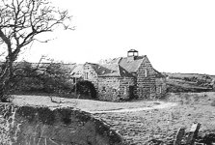
It was near the Mill of Durn that the Chapel of Durn was situated.

From the Scottish Guardian, 24th. September 1880;
ST. JOHN THE BAPTIST CHURCH, PORTSOY - This charge was in no doubt that “New Durn” was its parent. The ruins of the Chapel of New Durn are still to be seen on a little haugh, by the burn side, a little below the Mill of Durn, about a mile distant from Portsoy. Little is known of the past history of the Episcopacy in this immediate neighbourhood, but it is supposed that the Chapel of New Durn was erected under the sheltering wing of the Dunbars of Durn about the time that Episcopacy was supplanted by Presbyterianism. The Chapel of New Durn was burned down on 10th. April 1746 and the minister the Rev. Mr. Hamilton and his family had to flee for their lives; they, and the congregation paying this penalty for their devotion to the House of Stuart. The Communion Cup was rescued by a staunch adherent of the Faith, rolled up in the Altar Cloth and hidden in a stone dyke close by, until such time as the spoilers had done their fiendish work. This Cup is still used in St. John Baptist’s Church here but the Altar Cloth has long since crumbled to dust.
No attempts seem to have been made to rebuild the Chapel of New Durn, but when all fears of an outbreak of the rebellion subsided, the scattered members of the church drew together and met for worship in a room in the house known as the “lodging” which stands betwixt the Old Harbour and the Seatown and is said to have been erected in 1696 as a jointure house for a dowager of the Boyne family, the Rev. Mr. Mitchell, Arradoul, occasionally officiating.

From “A History of Portsoy Churches” published in 2000 by Portsoy Parish Church:-
AFTER THE BURNING OF THE CHAPEL OF DURN - The Episcopalians met in private houses and were ministered to by clergy from Banff and Arradoul. As and when both “Bonnie Prince Charlie” and his son “The Young Pretender” died, the threat of another rising receded, and in 1792 Bishop Skinner managed to get the “penal laws” repealed. As the enforcement of “penal laws” became slacker, so the Episcopalians became bolder and began to meet in a room in the house known as “The Lodging” near the Old Harbour, built as a dower house for the Ogilvies of the Boyne in 1699, and demolished prior to the Second World War. The congregation grew and moved to a loft in “The Old Cullen Road”. The repeal of the “penal laws” made the building of a church possible. A small chapel was opened at the east end in 1978 on a site in South High Street. It was entered from the west, the altar was at the east end and the pulpit was at the centre of the north wall. Accommodation for the minister was above the chapel. This building, and the addition of a wing running from north to south, became the Rectory between 1842 and 1952. It is still in use as a dwelling house next to the coffee shop.
The congregation grew and in 1841 the present building was opened. It was re-roofed and refurbished inside with items from St. Mary’s, Cullen in 1959. The pulpit, lectern and pews came from Cullen and the altar rails were made and gifted by Mr. Charles Stewart, joiner at Fordyce. The Communion Cup rescued from the Chapel of Durn is no longer used regularly. A more modern chalice and paten were gifted by public subscription in memory of the late Rev. John R. Brown - rector from 1914 to 1952 - who served as a Town Councillor and Provost of the Burgh and took an active part in all aspects of Portsoy life. The congregation worships every Sunday at 9.15 a.m. and shares its priest with All Saints, Buckie and since 1998 with St. Andrew’s in Banff.

1840 - EPISCOPALIAN CHURCH -
From the "Registers of Births, Deaths and Marriages of the St. John the Baptist Chapel" by A. Strath Maxwell, Aberdeen. 1989 With the relaxation of the penal laws the nucleus of the congregation began to meet in a house between the old harbour and the Seatown. In 1797-98 they moved to South High Street to a Church which was converted into a rectory when the present Church of St. John the Baptist was built in 1841.
A silver chalice in the possession of the church bears the inscription "Presented to the Chapel of New Durn. 1741.”
The congregation was linked with Banff in 1957 but a re-organisation brought a linking with Buckie in 1977.

From the Banffshire Journal Annual 1979:-

Extracted from THE STORY OF A BUILDING by J.D.G. McLeod
While the harsh penal laws after the ’45 Rising prohibited the holding of services for more than five persons at a time, the local Episcopalians must have held together and, as these laws were relaxed or unenforced, they began to meet openly. There was no attempt to rebuild the Chapel of New Durn. Instead the congregation met in Portsoy with services being provided from Arradoul and later from Banff. During this period, two meeting places are known. One was a room in the house known as the “Lodging” or the “Ritchies” near the Old Harbour, built in 1699 as a dower house for the Ogilvies of the Boyne. This building was demolished in pre-war days and the site is now occupied by public lavatories and a car park.
A larger meeting place becoming necessary, the congregation moved to what was later described as a “loft in the Old Cullen Road.” It seems reasonable to suggest that this could be the old store on the north side of Culbert Street. (Before Seafield Street was formed to by-pass the old town and before streets were named, the road to Cullen included Culbert Street – formerly known as “Culbert Rig” and earlier referred to as the road leading to John
Cuthbert’s “Rigs.”)
In 1798 the congregation again had a church of their own and, in the following year, a Rector of their own (Reverend J. Cardno 1799-1812). The Church was erected in South High Street (now part of the house named “The Haven”). It was a long plain building entered from the west. The altar was in the east end and the pulpit was at the centre of the north wall.
The Reverend Charles Grant (1812- 1828) was a classical scholar and in addition to his duties as Rector, taught a class for more advanced pupils, thereby laying the foundations for the Grammar School (now “Sunnybank” in Seafield Terrace). Among his pupils was Mr. Fleetwood Pellow Wilson whose family resided at 16 The Square. In later years, Mr. Wilson donated to the town the clock which dominates the centre of the town (and disturbs Station Hotel visitors). Another member of the Church at this time was Miss Elizabeth Bond who headed the Ladies’ School (now the Boyne Hotel).
A noteworthy Rector was the Reverend Alexander Cooper (1834-1864). He it was who set himself the task of raising funds for a new building of a size and quality to meet the needs of the congregation. In 1840 the present St. John’s was completed, the architect being James Ross a native of Portsoy. At the same time, the South High Street building, with wing added, was converted into a Rectory. Among the office bearers of the Church at this time were Adam Longmore Minty and George Shand, Senior, Ordens. Mr. Minty was one of two bachelor brothers who were prominent businessmen in their day and remembered today by anyone who refers to the Salvation Army Hall as “Minty’s Hall.” Mr. Shand and his family were faithful workers for St. John’s apart from contributing substantially to the Endowment Fund. The Reverent Cooper continued the Church’s contribution to education. He and the Reverend Peter Murray of the Established Church originated and built the Durn Road School (now “Meadowvale”).
In 1953 the Rectory in South High Street was sold, and in its place, 1 Barbank Street,was purchased. Having in mind the pre-1798 links with the congregation at Arradoul (later transferred to Buckie) and Banff, history appears to be repeating itself because Portsoy and Banff shared a rector from 1958 to 1970 and, since then, Portsoy and Buckie have had a similar arrangement. By 1966 it became obvious that a Rectory was no longer required in Portsoy and No. 1 Barbank Street was sold.

MEMORIAL WINDOW IN EPISCOPALIAN CHURCH - There has just been placed in St. John's Episcopal Church here a beautiful memorial window. Operations have been going for some time in connection with its erection, but the work has now been completed. The spot selected is a centre one on the south side of the edifice. The window, the freestone of which has all been renewed, is arched, with a couple of centre columns, the upper portion being divided into three sub-sections. This piece of excellent workmanship was executed by Messrs. William Alexander & Son.
But the artistic and costly work in stained glass is the chief attraction. At the bottom of the three panels inscriptions are inserted showing forth to whose memory the window has been placed there. Beginning at the left hand side the inscription reads:- "In memory of Edward Pellew Wilson, who died at Bahia, S.A., 11th November 1887, aged 87 years." The inscription which occupies the centre panel reads:- "In memory of Alexander Wilson, R.N. who died at Portsoy 24 Sept 1817 aged 43 years." The panel to the right contains the following inscription:- "In memory of Fleetwood Pellow Wilson, who died at Bournemouth 24th. April 1888, aged 77 years." (Note:- Fleetwood Wilson gifted the town clock to the citizens of Portsoy) Underneath, on a freestone tablet, which also forms the base of the window, there appears the following in large raised letters:- "Erected by Mrs. Ann Wilson or Murray, widow of the Rev. Peter Murray, in loving remembrance of her father and brothers."
The window has an exquisite appearance, and bears traces all over of very careful manipulation as well as mechanical ingenuity. The first to catch the eye is a representation of the Ascension. The Saviour with hands uplifted, as if uttering the last farewell, occupies a centre position, while around him are grouped the eleven, the countenance of each bearing traces of wonder and amazement. There is a beautiful blending of colour all through, and in every detail due attention has been paid to the artistic. The glass work reflects credit on Messrs. Powell Brothers, Leeds, who also sent one of their workmen to Portsoy to place it in position. The entire work was completed satisfactorily under the supervision of Mr. Ross, architect, Inverness.

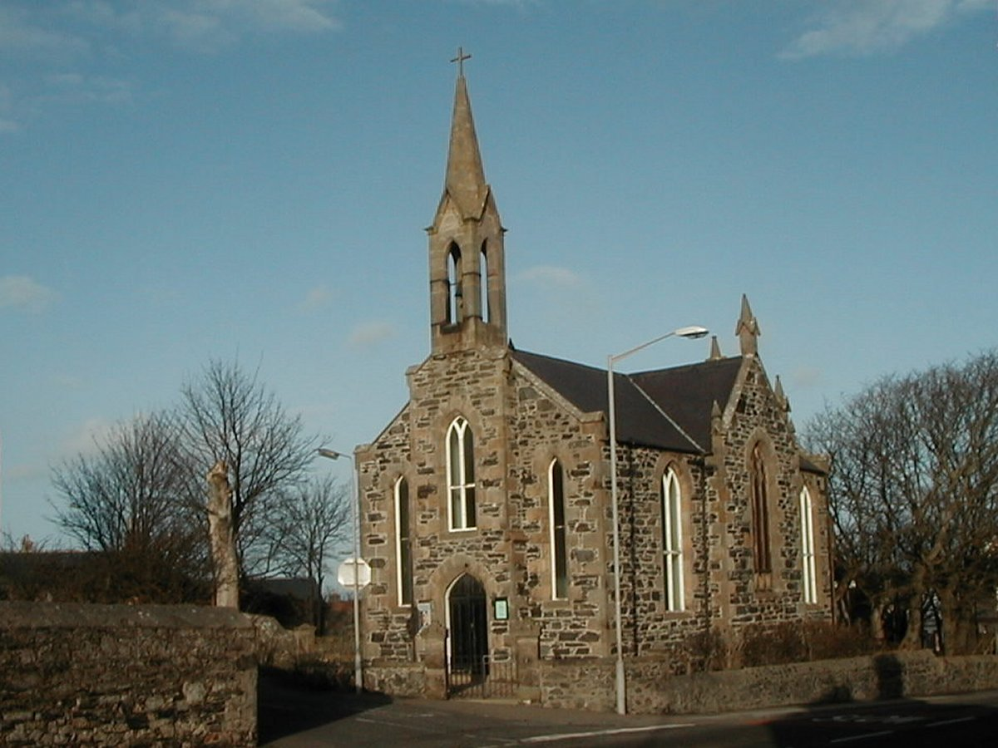

THE ROMAN CATHOLIC CHURCH

From “A History of Portsoy Churches” published in 2000:-
Before the Reformation, the Parish Church for the area of Portsoy was in nearby Fordyce ; and part of the ruins can still be seen in the Old Churchyard there. In the Post Reformation period a priest was frequently stationed at Auchintoul of Marnoch, and covered the Portsoy - Banff area from there.
In 1790 a small congregation of Roman Catholics assembled in Portsoy and had their place of worship on the Braeheads (an area near the present swimming pool) at the west-end of the house occupied by Mr. James Ross, and certainly their numbers must have been few to find accommodation in such a small building.
From 1795, a priest was in residence in Banff and again Portsoy was covered from there.
Afterwards when they became more numerous, they purchased and fitted up as a chapel, that house in the Low Street which is now Burnside Distillery. In 1827, the priest at Banff shifted from there and took up residence in Portsoy. That year an Alexander Grant, a young man of twenty-three years of age, came to Portsoy and he started planning a new Church. The Burnside building served as the Church for some twenty-eight years until 1829 when the present Chapel was built.

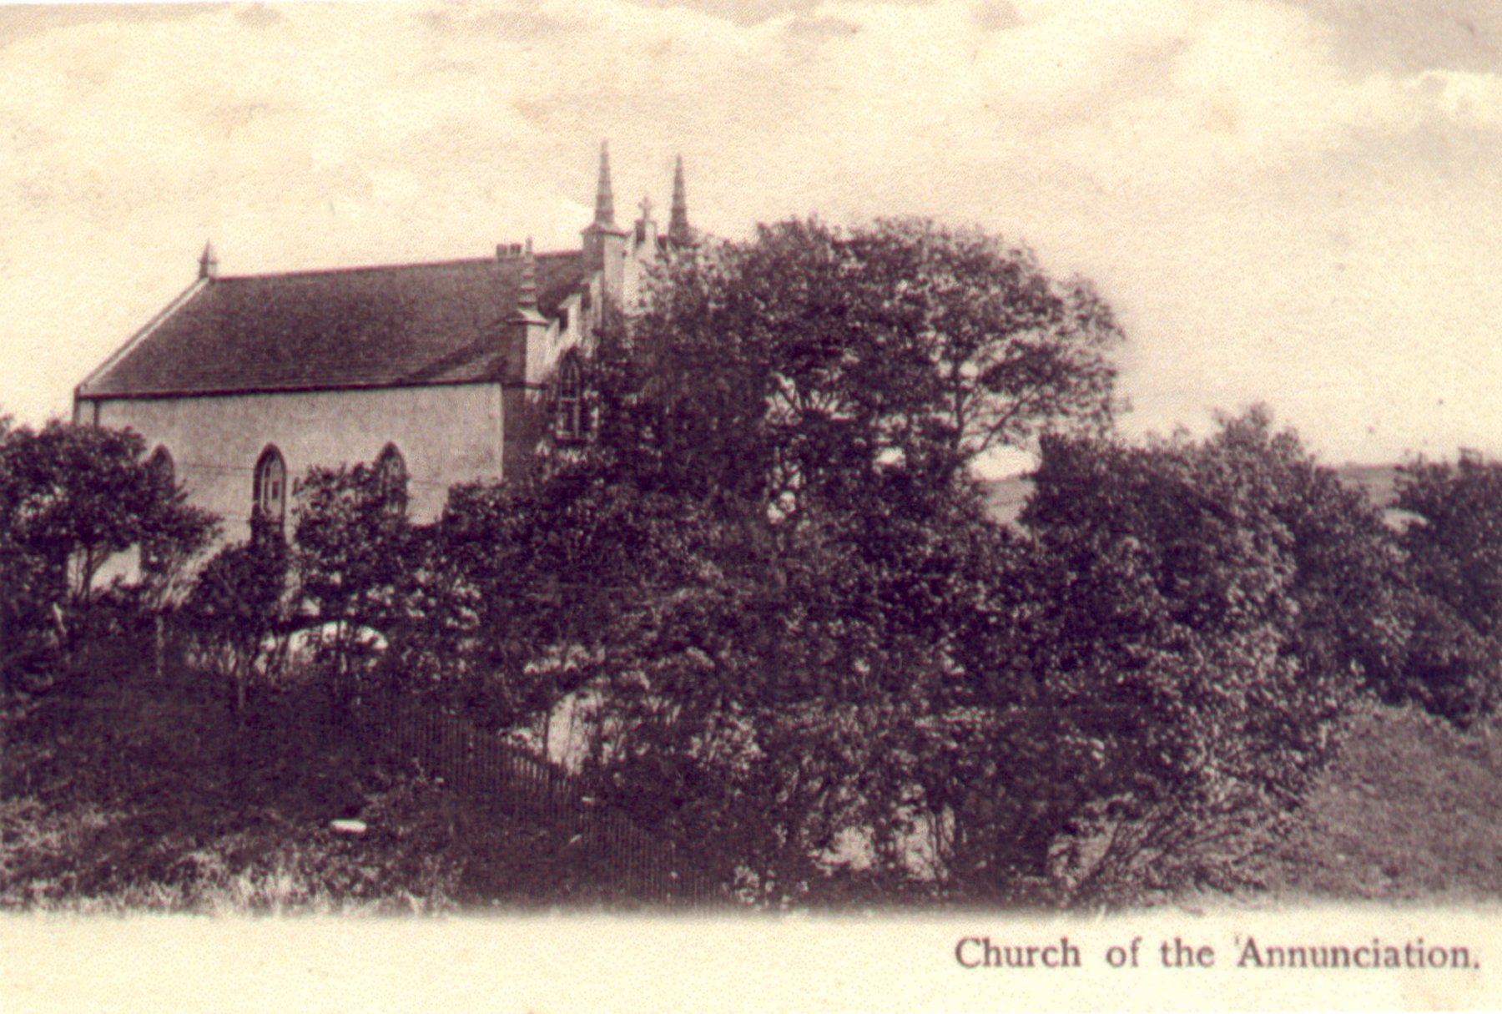

CHURCH OF THE ANNUNCIATION, PORTSOY.
Work on the project commenced at the beginning of May 1829, and the Church, plus part of the present house, was completed by December. The work had cost the sum of Three Hundred and Sixty Pounds.
It is a neat and commodious building calculated to contain 250 sitters. It has four minarets on the south gable, the apex of which is surmounted by a cross. It stands on a high bank above the loch and overlooks the approach to the town from the south and east. The entrance is in the south gable and on the left hand side of the vestibule is the vestry and on the right the staircase to the organ gallery. This gallery is at the south end and contains an excellent organ presented to the Banff congregation by the Earl of Fife. The altar is at the north end, and on the side of it stands the pulpit. On the communion table is placed a handsome tabernacle and on the wall above it are the names of the Roman Catholic clergymen who have had charge of this congregation. viz. :-
Mr. William Reid removed to Keith.
Mr. James MacLaughlan removed to Huntly
Mr. John Forbes removed to Elgin.
Mr. Alexander Grant died February 1833.
Mr. William A. Stuart removed to Preshome.
Mr. George Augustine Griffin appointed 1836.

The Church was formally opened by Bishop Kyle on the 13th. of December 1829 and is similar in style to the Church of Our lady of the Assumption built in Dufftown in 1825
During the incumbency of Mr. Grant and chiefly by his exertions, the new Chapel was erected to which Mr. Macnaughton has lately added a neat parsonage house besides greatly improving the approach to it from Burnside Bridge and planting a garden and shrubbery. Alexander Grant, unfortunately did not enjoy his new Church for very long, as he died in 1833 at the young age of twenty-nine

1829 ROMAN CATHOLIC CHURCH BUILT.
From the Portsoy Manuscript of 1843 by Dr. George Greig: -
Towards the end of the last century a small congregation of Roman Catholics assembled here and had their place of worship on the Braehead at the west-end of that house occupied by Mr. James Ross and certainly their numbers must have been few to find accommodation in such a small building. Afterwards when they became more numerous, they purchased and fitted up as a chapel, that house in the Low Street which is now Burnside Distillery. In 1829 the present Chapel was built. It is a neat and commodious building calculated to contain 250 sitters. It has four minarets on the south gable, the apex of which is surmounted by a cross. It stands on a high bank above the loch and overlooks the approach to the town from the south and east. The entrance is in the south gable and on the left hand side of the vestibule is the vestry and on the right the staircase to the organ gallery. This gallery is at the south end and contains an excellent organ presented to the Banff congregation by the Earl of Fife and by them allowed to be transferred here. The altar is at the north end, and on the side of it stands the pulpit. On the communion table is placed a handsome tabernacle and on the wall above it are the names of the Roman Catholic clergymen who have had charge of this congregation. viz. :-
Mr. William Reid removed to Keith.
Mr. James MacLaughlan removed to Huntly
Mr. John Forbes removed to Elgin.
Mr. Alexander Grant died February 1833.
Mr. William A. Stuart removed to Preshome.
Mr. George Augustine Griffin appointed 1836.

From “A History of Portsoy Churches” published in 2000:-
CHURCH OF THE ANNUNCIATION, PORTSOY - In the year 1898 extensive restoration work to the interior of the Church was found to be necessary, as the woodwork in particular, was in a very bad state of repair. At the same time, and following a design produced by the Aberdeen architects Messrs. Smith and Kelly, the internal layout was altered to improve the seating accommodation, and a semi-circular apse was added. On the completion of the work, a solemn High Mass was celebrated by the Very Rev. Monsignor Chisholm, then the rector of Blairs (he subsequently became Bishop of Aberdeen) and once again the Church was back in use for public worship.
Little or no alterations to the Church took place over the years, until 1937, when Fr. J. Bonnyman, then Priest in charge, was responsible for the installation of the present altar, with the invaluable assistance of a legacy from a Mr. John Cruickshank. He was also responsible for the redecoration of the interior. This work was undertaken with the advice of the late Peter F. Anson and that of the Poet Laureate, John Betjeman. The present front door was formed and the vestibule and Choir Loft remodelled in 1964.
The Church of the Annunciation is a neat and commodious building, designed to seat 250 people, and stands on a high bank above Loch Soy, overlooking the approach to the town from the south and from the east. The Church entrance is on the south gable, which is quite grandly treated, with four pilasters of stone, each of which terminate in a pointed minaret. The windows are in the gothic style with surrounds of stone, and the walls simply harled. The gable is completed with a stone cross mounted on the apex. When you enter the vestibule, the Vestry is to your left and the staircase to the Organ Gallery to your right. The Gallery contains an excellent organ, originally presented by the Earl of Fife to the Banff congregation but later transferred to Portsoy. The Altar is located at the north end of the Church, and to the side of it stands the Pulpit.

From “A History of Portsoy Churches” published in 2000:-
CHURCH OF THE ANNUNCIATION, PORTSOY - In the year 1898 extensive restoration work to the interior of the Church was found to be necessary, as the woodwork in particular, was in a very bad state of repair. At the same time, and following a design produced by the Aberdeen architects Messrs. Smith and Kelly, the internal layout was altered to improve the seating accommodation, and a semi-circular apse was added. On the completion of the work, a solemn High Mass was celebrated by the Very Rev. Monsignor Chisholm, then the rector of Blairs (he subsequently became Bishop of Aberdeen) and once again the Church was back in use for public worship.
Little or no alterations to the Church took place over the years, until 1937, when Fr. J. Bonnyman, then Priest in charge, was responsible for the installation of the present altar, with the invaluable assistance of a legacy from a Mr. John Cruickshank. He was also responsible for the redecoration of the interior. This work was undertaken with the advice of the late Peter F. Anson and that of the Poet Laureate, John Betjeman. The present front door was formed and the vestibule and Choir Loft remodelled in 1964.
The Church of the Annunciation is a neat and commodious building, designed to seat 250 people, and stands on a high bank above Loch Soy, overlooking the approach to the town from the south and from the east. The Church entrance is on the south gable, which is quite grandly treated, with four pilasters of stone, each of which terminate in a pointed minaret. The windows are in the gothic style with surrounds of stone, and the walls simply harled. The gable is completed with a stone cross mounted on the apex. When you enter the vestibule, the Vestry is to your left and the staircase to the Organ Gallery to your right. The Gallery contains an excellent organ, originally presented by the Earl of Fife to the Banff congregation but later transferred to Portsoy. The Altar is located at the north end of the Church, and to the side of it stands the Pulpit.
In 1969, Portsoy ceased to be a separate Parish and was joined once again to Banff.

FREE CHURCH OF SCOTLAND

1843 -DISRUPTION - FREE CHURCH ERECTED IN SEAFIELD TERRACE
From the Portsoy Manuscript of 1843 by Dr. George Greig :-
In June last a considerable number of the congregation seceded along with the Rev. Alexander Reid and joined what is called the Free Church of Scotland. They erected a commodious place of worship on the Hill of Portsoy near the Grammar School capable of containing 620 sitters. It is a large low building 65 feet by 50 feet having two roofs and four gables and a strong beam running the whole length of the Church supported by four cast iron pillars for sustaining the roofs to the centre. It has no galleries, the back seats being raised in the manner of a gallery and the pulpit is on the north side. On the north-east gable is a belfry containing an uncommonly fine toned bell.

Banffshire Journal, Tuesday, May 16th 1865 :-
MONUMENT TO THE LATE REV. ALEXANDER REID - A beautiful tablet of white marble has been erected in the Free Church here to the memory of its late respected pastor, the Rev. A. Reid, the cost (upwards of £30) being defrayed, not alone by the Free Church congregation, but to a considerable extent by the public. It bears the following inscription:-
"To the memory of the Rev. Alexander Reid, M.A., for 33 years minister at Portsoy. Born at Strichen, Nov. 21 1801 ; ordained minister at Portsoy June 18th. 1820; left the Establishment May 18th 1843, and became minister of the Free Church, Portsoy. Died February 7th. 1863, aged 62 years. Erected by his sorrowing congregation and the community of Portsoy generally, to whom his name is fragrant of all that is affectionate and faithful in the ministry of the Gospel."
The tablet also contains the text:-
"Therefore watch and remember that I ceased not to warn every one night and day with tears - Acts XX 31".

Banffshire Journal, Tuesday, January 21st. 1868 ;-
REPAIRS REQUIRED TO PORTSOY FREE CHURCH - A congregational meeting was held in the Free Church here on the evening of Wednesday last, for the purpose of having a statement submitted to them by their pastor, the Rev. W.W. Peyton, regarding the condition of the building in which they at present meet for public worship. In course of the statement made by Mr. Peyton, he said the present Church would, in the course of a very short time, require considerable repairs. It was very uncomfortable as a place of public worship, and very difficult to speak in, owing to its peculiar and very inconvenient structure. Moreover, the whole building presented a very clumsy and ungainly appearance. The Managers of the Church Building were averse to the bestowing of grants for repairs, while they would be willing to assist in the erection of a new church, after a plan more adapted to meet the requirements of the congregation. Mr. Peyton also stated that he would undertake to collect a certain proportion of the sum required for the new building, provided the congregation would raise a certain sum which he named; but that under no circumstances whatever would they proceed with the proposed building until they saw the way clear to do so, without incurring debt. The congregation, we understand, have entered heartily into the project, and will doubtless subscribe with liberality and heartiness, which are so characteristic of the adherents of the Free Church. We trust funds will not be found awanting to carry into execution the proposed plan ; for a more inelegant and inconvenient structure than the present Free Church of Portsoy could not well be imagined. And it is to be hoped that the liberality of wealthier districts will be ready to assist the congregation in erecting a comfortable and commodious place of worship.

Banffshire Reporter, Friday, July 29th, 1870 :-
PORTSOY NEW FREE CHURCH - Laying of the Memorial Stone by the Earl of Kintore. Yesterday, at three o'clock in the afternoon, the Memorial Stone of the new Free Church of Portsoy was laid in Masonic form by the Right Honourable the Earl of Kintore, in presence of a large number of clergymen, members of the congregation and others.
But before proceeding to notice the interesting ceremony, we may say a few words about the church itself. The original Free Church of Portsoy was one of those somewhat clumsy and awkward looking buildings which were got up in the need and hurry of Disruption times. In fact, though occupying a commanding and conspicuous position on the side of the public highway to Cullen, its architectural defects were so great as to excite the notice, if not the censure, of every stranger of taste who saw it. In addition to this, its internal defects were as great as its external defects were.
Some three years ago, according to a statement made by Mr. Peyton at the ceremonial, the idea of a new church was first suggested by the Rev. William Wilson, Dundee, Convenor of the Home Mission Committee. This idea is now being carried out, and as the negotiations and so on in regard to the building will be fully explained in the report of a short address which was delivered by the Rev. Mr. Peyton, we shall here confine our observations to a brief description of the new building.
After looking at various sites and fully weighing the whole matter, the building committee finally resolved not to build an entirely new church, but rather to rebuild the old one, and this led to the plan of the church being somewhat different from what it doubtless would have otherwise been. The style of the building is a sort of mixed, or decorated Gothic, with a gable front, in the centre of which is the only entrance, which is very spacious, lofty and pointed at the top. Over the entrance is a circular window of 9 feet diameter, which will be filled with stone tracery and coloured glass. There is a corresponding window of the same form but of larger size in the west gable, which will also be partly filled with tracery and stained glass. On the right hand side of the entrance there is a buttress column which will be surmounted by an elaborately carved finial; while the apex of the east gable will be surmounted with a large and elegant cross. But the main feature of the building is the tower and spire, which is situated at the south-east corner, and from the high position in which the church stands, will be a very conspicuous object. The height of the tower is 34 feet, and as the height of the spire is 56 feet, the height of the whole will be 90 feet, which is 10 feet less than was originally intended. The tower, like the rest of the front gable is built of the common blue boulder stone of the district, squared, with freestone corners, and the spire will be of dressed freestone.
The area of the church inside is 67 feet by 47 feet. There is thus a very long span of roof, but the weight of it will be partly supported by large transverse beams, and it will be divided into two aisles and a centre transept. The pulpit, which was formerly in the north, will now be placed in the west, under a large circular window, which will throw a flood of light into the body of the church independent of the large side windows. There will be no gallery, and we presume there will be no vestry, but a covered passage will form a direct communication betwixt the church and the manse. Having thus endeavoured to give a faint description of the church, we must turn to the proceedings at the Masonic ceremonial.
This, as we have stated, was arranged to take place at three o'clock, and by the hour appointed a large number of people of all denominations had assembled to witness it. But it was given to few to witness the actual ceremony, as the memorial stone is in the basement

course of the spire, towards the south, so that only a few could find standing room near it. The religious part of the ceremony commenced by the Rev. Mr. Peyton giving out the first three verses of the Hundredth Psalm, which having been sung, he then said that he would call upon the Rev. Alex. Spencer, Cornhill, the oldest member of the Presbytery, to engage in prayer. Mr. Spencer having offered up an impressive prayer, Mr. Peyton then said that it was usual to say a few words upon such occasions, and he would do homage by observing the good old custom, though he would best consult the convenience of the meeting by studying brevity. He would only occupy five minutes, and for the sake of perspicuity he would read what he had to say.
The idea of a new church at Portsoy originated with Dr. William Wilson, Dundee, Convenor of the Home Mission Committee, whose eye is over all the Church, and whose heart is ever thinking and planning for the interest of this noble Free Church of ours in every district of the country. The old building, full of the memories of the Disruption and of the holy ministry of my late predecessor, has done its work well. Three years ago we began to think of a new building, and slowly materials have been gathering, which now take the shape you see, and which I trust, with God's blessing, will take a more perfect shape very soon. The principle which we have kept in view in the architecture of this church is this : that the style should suit any advanced period in the history of the country. It is a mistake to entail upon every generation the enormous labour of church building. What is now done should be done in a style and manner to suit enlarged ideas, and means, a hundred years hence - as long as stone and lime will last.
Accordingly we got a plan, with a tower and spire 100 feet high. It was not intended to finish the spire. We were to go to the length of £1000, and the rest could have been done years after this. I am happy, however, to say that Mr. John Allan, our respected elder, has got the town and districts interested in the building, and has received contributions from all denominations to finish the building. I may here acknowledge the liberality of the members of the Church in Glasgow and Edinburgh, who give so generously to the help of our country districts. I must also here express my obligation to sixty ladies of the Free Church, north, south, east and west, who have raised something like £110, by collecting cards. The highest sum raised in this way was £7, and the lowest 8s.6d..........
At the close of his address, Mr. Peyton, then stated that Lord Kintore would now proceed with the ceremonial of laying the Memorial Stone. His Lordship then proceeded to ascend to the tower, accompanied by the Rev. Mr. Peyton, Mr. Barclay, the contractor for the mason work, a few of the operative masons, and as many others as could find standing room. The bottle containing the usual documents having been placed in the cavity of the stone, Mr. Barclay laid on the mortar in the first place, after which Mr. Peyton handed to Lord Kintore a silver trowel, with which his Lordship skilfully but very lightly smoothed the mortar. The memorial stone, which forms a covering to the cavity, was then lowered into its place, and his Lordship having been handed a mallet, he gave the stone three firm masonic knocks, and then said he declared this ceremonial of laying the Memorial stone of the Free Church of Portsoy completed. The party then descended to the front of the hewing shed, when Mr. Peyton stated that Lord Kintore would now deliver an address.Lord Kintore then said - Rev. Mr. Peyton and members of the Free Church of Portsoy, my Christian friends, it has given me very great pleasure to be here today, and to hear the excellent address to which we have listened. I hardly know what I can say to supplement what remarks have been made. We are here today under the canopy of God's blue heaven, a foundation of all Christian Churches, even Christ, the same yesterday, today and forever. The noble earl gave a long, eloquent, and highly evangelical address, dwelling with particular force on the obligations in which Christians lay
evangelical address, dwelling with particular force on the obligations in which Christians lay in making endeavours to spread the Gospel.
He said that while he thought the members of the Free Church ought to see thoroughly after the interests of their own persuasion, they ought to be tolerant towards all others; and while they deplored the circumstances which led them , however unwillingly, to separate themselves from the sister church, they ought to make it their continual prayer that they might at no distant date give each other the right-hand of fellowship in Christ. He also hoped that there might be an early union between the Free and United Presbyterian churches. This was not the first time he had paid a visit to Portsoy, and he paid a solemn tribute to the memory of departed friends who had accompanied him on the mission in which he was then engaged. He again thanked Mr. Peyton and the congregation for the honour they had done him, and repeatedly expressed his pleasure in being the object of that honour.
We are exceedingly sorry that we are compelled by want of space to abridge the speech of the noble earl which was worthy of being given in full.
At the conclusion of the noble Earl's very able and impressive address, which was listened to with deep attention, Mr. Peyton stated that the bottle contained copies of the Daily Review, Banffshire Reporter, Banffshire Journal, Free Church Record, and Public Accounts of the Free Church, along with a document containing the names of the Ministers and Office-bearers of the Church; the architect and the contractors; the amount of contract - £1200 ; and stating that the memorial stone was laid by the Right Hon. the Earl of Kintore, 28th July 1870. The stone, we may here observe, bore some masonic characters, and the date "1870".
The Rev. Mr. Peyton, in a few words in his own name and the name of the congregation, then presented his Lordship with the silver trowel with which the mortar was spread at the ceremonial, as a souvenir of the event.
The Earl of Kintore, in reply, said :- Rev. Mr. Peyton and friends, I have to thank you for your kind remembrance of me today. I promise, as I receive this gift from you, to take it home, and not only that, but preserve it as a family heirloom.
The Rev. Mr. Peyton then read the 122nd. Psalm, from the 6th. verse to the end, which was sung by the whole company.
During the whole of the latter portion of the proceedings Lord Kintore held the silver trowel in his hand, so that the company might see it. The handle is of ivory and the blade is both massive and elegant, the border being formed of masonic emblems. It was furnished through our townsman, Mr. Leys, watchmaker, and bears the following inscription, beautifully engraven on the blade:- "To the Right Honourable the Earl of Kintore on the occasion of his laying the Memorial Stone of the Free Church of Portsoy, Banffshire. 28th. July 1870."
The Rev. Mr. Peyton afterwards pronounced the blessing, and the company separated.

Banffshire Reporter, Friday, November 18th 1870 :-
FREE CHURCH SPIRE :- The spire of the new Free Church here has now been stripped of the scaffolding, and has a very smart and elegant appearance. We certainly do not altogether like the abrupt spring of the spire from the tower, but all above that, it is exceedingly chaste and elegant, and reflects much credit on Mr. Barclay, the contractor, who appears to have done the design of the architect much justice. As the Church occupies an elevated position, the spire will be quite a landmark, and will be seen by travellers coming either from the east or the west before any other portion of the town is visible. The interior work of the Church is advancing, but it must still be a good many months before it can be opened for worship.

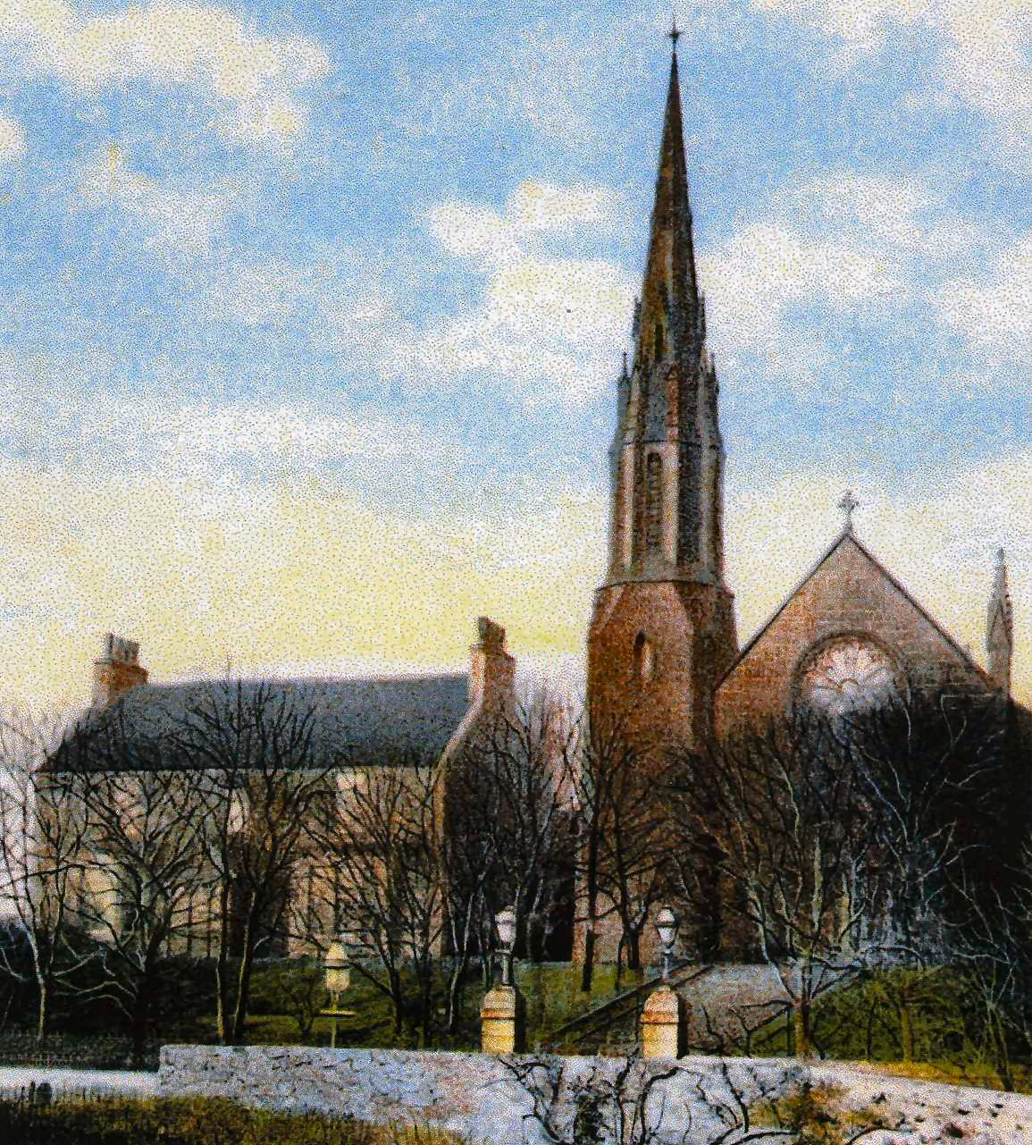
Portsoy’s Free Church and Manse

1929 UNIFICATION OF THE PRESBYTERIAN CHURCHES - The two remaining Presbyterian churches in the town came under the unification of the Church of Scotland, and were afterwards known as the East Church and West Church.

1955 ALMALGAMATION OF CHURCHES - The minister of the East Church retired and as there were already a vacancy in the West Church the obvious plan for the Presbytery was the union of these two congregations. The West Church (formerly the U.F. Church building) in Seafield Terrace, was chosen as the more suitable to be continued as the Parish Church. The former East Church was converted for use as a Church Hall.

CONGREGATIONAL CHURCH.

Banffshire Journal, Tuesday, September 18th. 1849 :-
INDEPENDENT CHAPEL, PORTSOY. The foundation of a new Chapel, in connection with the Independent body was laid at Portsoy on Tuesday last. (A more detailed report appeared in the Banffshire Journal the following week)

Banffshire Journal, Tuesday, September, 25th. 1849 :-
PORTSOY - INDEPENDENT CHURCH - In our last we noticed the laying of the foundation stone of a new independent chapel at Portsoy, on Tuesday, 11th. inst. A very interesting open air service took place on the occasion,

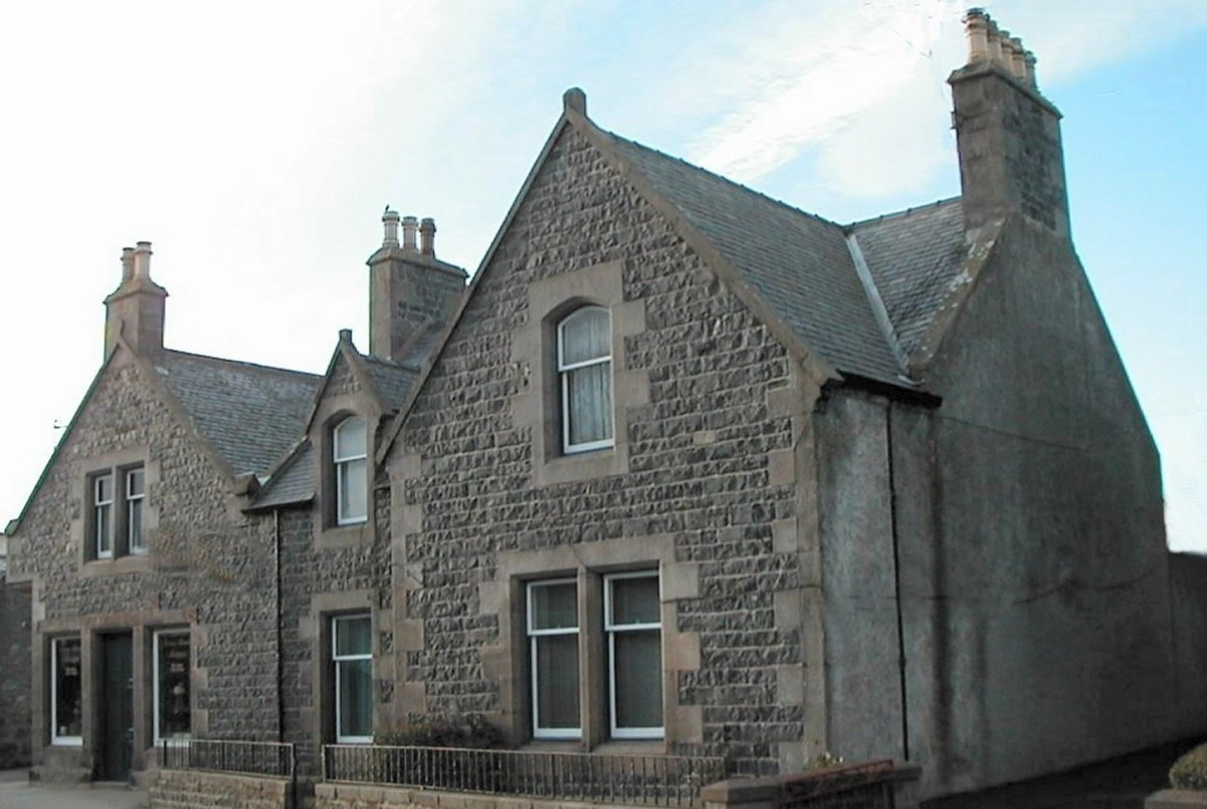
Congrgational Church, now an Antique Shop and Dwelling House. Photo L. McBain

Banffshire Journal, Tuesday, June 11th 1850:-
OPENING OF THE NEW INDEPENDENT CHAPEL, PORTSOY - The new Independent Chapel at Portsoy had divine service performed in it, for the first time, on Sabbath week, the 2nd. instant. The Rev. C.A. Piper of Cullen preached, in the forenoon from Psalm v. 7, and in the afternoon from Psalm cxxxvii 5-6 ; and the Rev. J. Murker of Banff preached in the evening from Rev. xxi. 22.
The attendance was highly encouraging at all the services - during the forenoon, the place was well filled with a most attentive audience; in the afternoon it was crowded; while in the evening it was not nearly sufficient to contain the congregation, so that many had to be accommodated with sittings in the adjoining vestry.
This neat and commodious erection is a very model of tasteful simplicity. Every department of the work is admirably executed. There is a completeness about the whole, seldom indeed to be met with in places of worship of higher pretensions. The apparatus for heating the place is so constructed, that the fire used for the vestry acts upon an air chamber, which admits the cold air from the interior of the chapel, and sends back two streams of warm air sufficient to heat the whole area of the chapel, in a very short space of time. An elegant timepiece faces the pulpit, and the vestry is commodiously fitted up for the prayer meeting, the bible class, and the Sabbath school ; it also communicates with the chapel by a door on either side of the pulpit, so as to afford additional seat-room, in case of an overflowing audience.
The collections at the opening services were liberal, although neither of the preachers uttered a single sentence on that subject. The preacher in the evening, before pronouncing the blessing, congratulated his brethren at Portsoy, on this successful termination of their anxieties and efforts; at the same time he reminded them that their responsibilities may be said to be only now commencing, for it is far more easy to erect places of worship than to live the gospel in all its heavenly effect on the spirit and conduct of its professors. He also expressed his own gratitude, and that of his people to the managers and teacher of the school in that town, for the use of the schoolroom, which, for years, had been so generously granted to him and his people, for occasional religious services. At the same time, he acknowledged deep obligations to the many kind friends in the quarter, who had aided by their countenance and unsolicited contributions, for, although in no case had anyone belonging to another denomination been asked for a subscription, yet many had come forward to assist the funds of this house of prayer.

Banffshire Journal, Tuesday, January 20th 1863 :-
INDEPENDENT CHURCH SOIREE - A soiree was held in the Independent Chapel here on Monday night last, the 12th.inst. The Chapel was crowded by a deeply interested audience. The Rev. R.H. Irvine occupied the chair. Addresses were delivered by the Revs. R. Troup, MA, Huntly, on the "Past History of Missions in Madagascar in Relation to their Present Prospects"; by Mr. George Will, to the Bible Class on "The Duty of Young Men Endeavouring to Rise in the World" ; by Mr.Taylor on "Aiming to be Good"; and by the Rev. G. Saunders of Millseat on "Memory" The proceeds of the soiree are to be devoted to the formation of a library for the use of the public Bible Class conducted by the Rev. Mr. Irvine.

Banffshire Journal, Tuesday, September 6th 1864:-
PORTSOY, SEPT 6TH - CONGREGATIONAL CHURCH - We were favoured last week by a visit from the famous Miss Graham, of Edinburgh, who held meetings in the Congregational Chapel on Thursday, Friday, and Sabbath evenings. On all these occasions, the chapel was crowded to overflowing by as respectable and attentive an audience as ever worshipped within its walls. It had been announced that these meetings were to be held for females only, but males also were admitted to a seat in the vestry. Miss Graham appears to possess that exceedingly rare faculty, of throwing her whole heart into the work that she is engaged in, and, from what we witnessed, we are inclined to believe that not a few were deeply, and we hope lastingly, affected by her earnest appeals and impassioned pleadings.

Banffshire Reporter, August 26 1903:-
A BANFFSHIRE WATERING PLACE - The time was when there was also an Independent Chapel; the site of which is now occupied as a substantial dwelling house dignified by the title of Chapel House. A remnant of the faithful adherents still remains to cherish the blissful memories of the past and the great and good work done by that sturdy Independent, John Murker - a name which is a household word all along the coast.
(Note :- The Independent Chapel closed during the nineteenth century but the precise date has never been discovered)

UNITED PRESBYTERIAN CHURCH

Banffshire Journal, Tuesday, February 9th 1864:-
SECEDERS FROM FREE CHURCH - The 'Seceders' from the Free Church met in the Hall for public worship yesterday and the preceeding Sabbath. The average attendance may be set down at 150, this however included not a few belonging to other denominations.

Banffshire Journal, Tuesday, December 19th 1865:-
THE U.P. CHURCH - The UP congregation have purchased a portion of the property of Mr. Mortimer, watchmaker, as a site of their new church. Building operations will commence early in January.

Banffshire Journal, Tuesday, March 6th.1866:-
LAYING OF THE FOUNDATION STONE OF THE U.P. CHURCH -Yesterday afternoon (5th March) the ceremony of laying the foundation stone of the Church for the United Presbyterian Congregation recently formed at Portsoy, took place there. The site of the Church is on Seafield Street on the feu of Mr. Mortimer, watchmaker. The building will be in the Gothic style.
...........The ceremony of laying the stone took place at four o'clock by which time a very large number of spectators had assembled. The day was clear but cold, a hard frost prevailing. The stone was laid in the south-east corner of the building, where a cavity was made to receive the relics usually deposited on such occasions.
...........The Rev. McDougall, having placed the bottle in it place, spread the mortar, ordered the stone to be lowered and applied the square and the level. He then declared the foundation stone of the United Presbyterian Church duly laid. (Extract from a lengthy report).
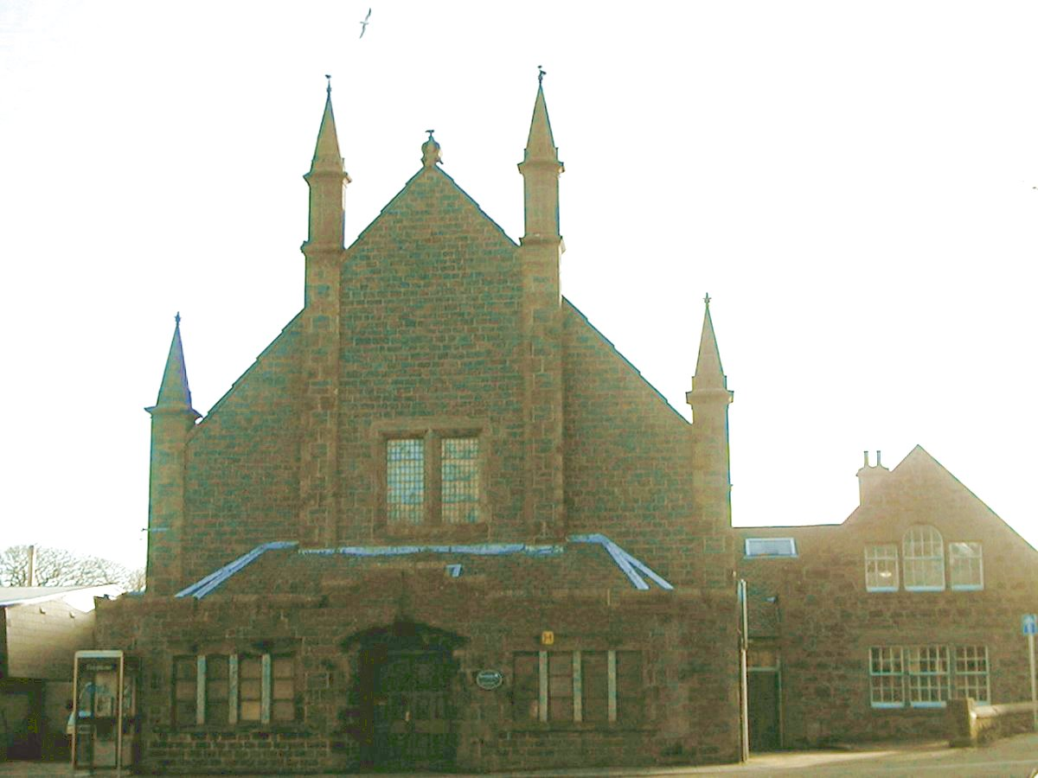
The United Presbyterian Church now the Town Hall. Photo – L McBain

Banffshire Journal, Tuesday, August 31st 1869:-
ERECTION OF UNITED PRESBYTERIAN MANSE - There has been added lately to the buildings of the town a handsome United Presbyterian manse, which stands on a large feu on the west entrance to the town on the Cullen turnpike road. The house was designed by Mr. Easton, and accepted by the manse board, who have given the half proportion of the expense incurred by the congregation on its erection which will amount to about £600 sterling. The contractor, Mr. Barclay, has executed the work in a way that has attracted special attention and the manse board have expressed their satisfaction to its elegance and finish. Mrs. Simmers the wife of the esteemed pastor is making arrangements for a sale of ladies' work to defray a portion of debt on the church building.

Banffshire Reporter, October 5th 1887:-
UNITED PRESBYTERIAN CHURCH - RE-OPENING SERVICES - After a lapse of four months, during which the building has undergone a complete renovation, the Portsoy United Presbyterian Church was re-opened for public worship on the forenoon of Sabbath last. The United Presbyterian body worshipping in Portsoy came into existence some twenty-two years ago, the induction services in connection with their first minister - the Rev. Nathaniel F. McDougall, Newabbey, Dumfries - having taken place in Mr. Minty's Hall on 21st. September1865. At this time they had no meeting place of their own, but shortly after Mr. McDougall had taken upon him the pastoral charge of the congregation, a site was obtained from the late Mr. Mortimer, watchmaker, upon which the present building was erected.
The internal arrangements of the church were far from satisfactory, however, and certainly did not coincide with the modern idea of beauty and comfort. About six months ago a committee was formed with the modest object in view of whitewashing the walls, painting the seats, and introducing an organ, but the funds increased so rapidly that it was decided to proceed with the complete renovation of the interior. This has been accomplished, and on Sunday last the congregation re-entered the building practically free of debt.
It was expected that a professor would have been able to conduct the opening services, but he was prevented from being present on this interesting occasion. It therefore devolved upon the Rev. Mr. Simmers to officiate himself. It was a double event, for apart from the re-opening of the church, there was also the introduction of music. ............ (Extract from a much larger report).

Note:- The United Presbyterian Church was situated at the corner of Seafield Street and Durn Road.

1913 ALMALGAMATION OF CHURCHES - On Sunday the 25th. May 1913 the last sermon was preached in the United Free Church - East (formerly the United Presbyterian Church). The following Sunday, the 1st. June, the congregation joined the congregation at the United Free Church - West, in Seafield Terrace. This church was now known as United Free Church, Portsoy.

Banffshire Journal, Tuesday, April 15th. 1919 :-
A PORTSOY CHURCH - Suggested Sale - A meeting of the congregation of the West U.F. Church, Portsoy, was held on Monday evening. It was called by the trustees and kirk session for the purpose of ascertaining the mind of the congregation as to the future of the old U.P. Church building which has been unoccupied since the union of the congregations about five years ago.
Rev. A.G. Campbell who was called upon to preside, read a letter from Mr. A. Bannerman Robb, solicitor, who is acting as secretary to the executive committee of the War Memorial Committee, in which he mentioned that the committee, in looking for a site for the proposed Memorial Institute Hall, had fixed upon the old U.P. Church as being the most suitable one to be got in the town, and asking the trustees if they would sell the church to the committee that it might be reconstructed and fitted up as a Memorial Institute Hall.
Provost Rae said the U.P. Church in his opinion never was, and he could not see how it ever could be of any use to them as a congregation . If it were made into a Church Hall, when once the alterations were made, the key would be turned in the door, and that would be the end of it.
Mr. Marcus Calder moved that this congregational committee grant liberty to the trustees to sell the furnishings of the U.P. Church, but with regard to the building itself, the meeting is of the opinion that it would be of great advantage to the congregational life, and especially to its social life if the building was utilised as a Church Hall, and the meeting accordingly request the trustees and committee of management to take the necessary steps in this direction at an early a date as possible. Mr. Calder pointed out that the motion was not put forward in opposition to the memorial scheme, but to admit of the usefulness of the church being extended so that its organisations could be carried on, not on Sundays alone, but on any day or every day throughout the week. He also stated that the congregation had no power to sell the building, it being distinctly laid down in the third clause of the basis of the union that the “East Church shall be used for congregational purposes.” Mr. Alex. Campbell, bank agent, seconded. The motion, he said, was brought forward in no spirit of antagonism to the memorial scheme, but to further the interests of the church in both its spiritual and social aspects.
The motion was supported by Mr. Alexander Findlater, Brodiesord, who urged them not to sell the church, as to some of them it was very dear and full of sacred associations and hallowed memories.
After a good deal of discussion of a rather heated nature, in which Mr. W. MacDonald, Mr. W. Ross, Mr.W.Milne, Mr. J. Reid, baker, and others took part, Mr. W. MacLean moved that the meeting grant liberty to the trustees to sell the church if they see fit. The purpose for which the building was intended was, he said, one of the best, most sacred and sweetest of schemes. What more sacred purpose could any building be put to, than as a memorial for those who have given their all and died for such a sacred cause.
Mr. W. Milne seconded and Mr. J. Reid, baker, supported the counter-motion.
After further discussion taken part in by the Chairman, Mr. MacLean and others, and as the feeling of the meeting was becoming somewhat tense, Mr. J. Reid, fruiterer, moved that the motion and the amendment be put to the vote and have it decided. On this being done, it was found that 42 voted for Mr. Maclean’s amendment, and 10 for Mr. Calder’s motion. According to Church Law and Deeds it requires a three-fourths majority of the congregation present at the meeting before the trustees have power to sell the church.

Note :- The U.P. Church was sold to the Town Council for a Town Hall in 1923.

OTHER RELIGIOUS DENOMINATIONS.

Banffshire Journal, Tuesday, April 2nd. 1867:-
RELIGIOUS FERVOUR AT PORTSOY - Several exciting meetings have of late been held in the Seatown, Portsoy, conducted by fishermen from the West. The result, in one case at least, has been to unhinge the mind of a quite respectable man, who has been attending the meetings. Yesterday, but for timely interposition, he would in all likelihood have lost his life. He now lies in a very critical condition.

Banffshire Journal, Tuesday, May 15th. 1923:-
THE SALVATION ARMY - Great success continues to attend the work of the Salvation Army in Portsoy.
The meetings during the week are always well attended, and on Sunday and special occasions the Town Hall is far too small to hold the crowds who wish to attend. The past weekend has seen an advance movement, when a new company was formed at Portsoy, and a Captain and Lieutenant straight from the training centre in London have been placed here to carry on the work.
A social meeting was held on Friday to welcome the two new officers, when the Town Hall was all too small to accommodate the audience. A number of sympathisers were present from other places. On Saturday and Sunday, Staff- Captain Rohn was present, and a number of meetings were held, both in the open air and in the hall. He had a great reception, and presented the Company with their flag, and introduced the new officers, Captain Stark and Lieut. Lee, who are both gifted musicians and excellent singers and speakers.
At the evening meeting in the Town Hall on Sunday there was a great gathering, and every inch of space was taken up, and many failed to gain admittance. The meeting was of a most impressive nature. A large number were enrolled as soldiers under the banner of the Army, and took the Army pledge to remain true till death.

Portsoy’s Religious History

Prior to 1741 the inhabitants of Portsoy belonging to the Established Church attended public worship at the Parish Church at Fordyce.

1741. Portsoy was made a preaching station and the first Presbyterian Church was situated at the lower end of Church Street (then known as Back Street) opposite the Burnside Distillery.

1746. The congregation of the Episcopalian Church was formed after the Revolution of 1689. Their Chapel of New Durn however was burned by the Duke of Cumberland’s Army on 8th April 1746 on their way to Culloden. This chapel was situated between Durn House and the Mill of Durn.

1746. A new Established Church was built at the junction of Church Street and Institute Street.

C1790 Towards the end of the eighteenth century a small number of Roman Catholics assembled in Portsoy, and had their place of worship on the Braehead at the west end of that house occupied by Mr. James Ross. Afterwards, when they became more numerous they purchased a building in Low Street and fitted it up as a Chapel.

C1790 With the relaxation of the penal laws the nucleus of the congregation of the Episcopalian Church began to meet in a house between the Old Harbour and the Seatown.

1798 The Episcopalians moved to a Church in South High Street.

1804 A building in Schoolhendry Street, at the rear of Seaview, originally erected by Dissenters, was taken over by the congregation of the Established Church, their present building being totally inadequate for their needs.

1815 The Established Church now erect a Church building on Seafield Street opposite the Station Hotel. This building is known as the “Aul’ Kirk”

1829 The Roman Catholics build the present chapel. It is sited on a high bank above the Loch of Portsoy, and overlooks the approach from the East.

1841 The Episcopalians built the Church in Seafield Terrace which is still in use Their previous Church in South High Street was converted into the Episcopalian Rectory

1843 A considerable number of the congregation of the Established Church seceded and formed the “Free Church” A church is erected on the “Hill of Portsoy” (later named Seafield Terrace) to hold 620 sitters.

1849 An Independent Chapel was erected in South High Street which was later known as the Congregational Church.

1864 Seceders from the “Free Church” met in the Hall for public worship. The United Presbyterian Church is formed and in 1965 they purchase property at the junction of Seafield Street and Durn Road to build a church.

1870 The memorial stone for a reconstructed Free Church with a spire, on its present site, is laid by the Earl of Kintore.

1876 A clock tower is added to the “Aul Kirk” in Seafield Street.

1881 The “Aul’ Kirk” is completely renovated and re-opened for worship in July.

1887 The United Presbyterian Church is renovated and re-opened for worship in October.

1914 The United Presbyterian Church joined with the Free Church in Seafield Terrace. The UP. building is sold to Portsoy Town Council in 1923 for use as a Town Hall.

1929 The two remaining Presbyterian Churches -The United Free Church and the Established Church are unified into the Church of Scotland . They are known as the East and West Churches.

1955 The congregations of the two Presbyterian Churches are united and the East Church is closed. The building is converted into a Church Hall.

ESTABLISHED CHURCH, FORDYCE

From the book "The Auld Kirk: The Auld School : Fordyce" by an unknown author in 1912.

Facts from a previous book "The Church of Fordyce" by Dr. Cramond :-

FORDYCE - "THE AULD KIRK"
The history of the "Great Kirk" began when Fordyce was Fuardeas and dates from the sixth century, when St. Talarican, a native Pictish saint, was made Bishop of the diocese by Pope Gregory.
King Alexander III in 1272 appointed Andrew de Garentuly bishop. The bishopric was of great extent - from the Deveron to the Spey. Fordyce was the centre which gathered, Sabbath after Sabbath, some 2000 people for the worship of the common God.
The manners and morals of the time may be deduced from the following records, 1624 -1674:-
"The minister, Mr. Darg, is found approven in doctrine and conversation and in his family. The officer, William Young, is found to be slack and remiss in allowing persons to be buried in the Kirk before they pay."
"The fishers in Portsoy, Reidhyth, and Sandend are found guilty of baiting their lines and gathering bait on the Sabbath day. The guidman of Glassaugh takes in hand to restrain all these Sabbath breakers."
"David and James Low had to stand in the jogs for two Lord's days for fearful cursing."
"Five persons absent from the Kirk - one fined half a merk, the rest excused."
"William Jack, Hallyards, fought with George Kelman in the Kirk in the time of the sermon. Had to satisfy three Sabbaths in sack-cloth."
"John Strachan for stealing a table-cloth is ordered to stand in the jogs in the time of divine service with the table-cloth about his neck."
The fishers of Sandend paid £3 13s for seats in the common loft, and the fishers of Portsoy, £4.

From the Fordyce Parish Church records, 18th. December 1709:-
ALLOCATION OF CHURCH SEATS - Intimation of Act of Kirk Session giving to the 'Seamen of Portsoy', rights to occupy seats in the loft of the Church of Fordyce equal to the rights already enjoyed by the seamen of Sandend

From the Fordyce Parish Church records , 16th. December 1721:-
ILLEGAL FISHING - George Wood and several other fishers in Sandend being summoned to the Session to answer for their going to the sea and fishing on Friday last, it being a Fast Day.

1741 - GREAT FAMINE
From the Fordyce Parish Church records:-
April 26th. - Condescended that in respect of the great poverty and dearth of victual a general distribution should be made of the 'Poor's Money'.
May 8th. - The minister and elders having met there was distributed to the poor £71/10/-
May 13th. - The minister represented that he had been considering the distressed state of the parish by the great dearth and scarcity of victual and therefore moved that the Session should advance what money they have in hand just now and give their obligation to any gentlemen that would lend them money for the purchasing of meal for the use of poor people in the parish - to both of which the Session unanimously agreed.
June 25th. - Thanks expressed to Captain Abercrombie of Glassaugh for advancing funds to the Session to purchase meals for the poor.
Nov. 1st. - Intimation was made of a thanksgiving to be observed next Thursday on account of the "plentiful harvest".

1741 - ABANDONED CHILD FOUND AT ARNBATH.
From the Fordyce Parish Church records:-
Sept 27th. - Session met and was constituted. A fatherless child having been dropped in John Ogilvie's house at Arnbath and nobody knowing to what place it belongs, it was agreed that 18 pence be given to the said John Ogilvie to take care of it until further enquiries be made.
Oct. 26th - Agreed that a peck of oatmeal be given weekly to Robert Runcie for maintaining the poor child left in John Ogilvie's
May 4th. 1746 - Ordered that the poor child in Robert Runcie's be dismissed to beg its bread and that the treasurer give something to buy clothes.

(Book 3/Churches & Religions) Revised : - 23 November, 2026

Not correct - Bonnie Prince Charlie was “The Young Pretender” and his father “The Old Pretender.”
The Rectory was the building next to the steps not the building known as the “Elms” next to the Coffee Shop
The Rev. John R. Brown was a Councillor but was never Provost of Portsoy.

