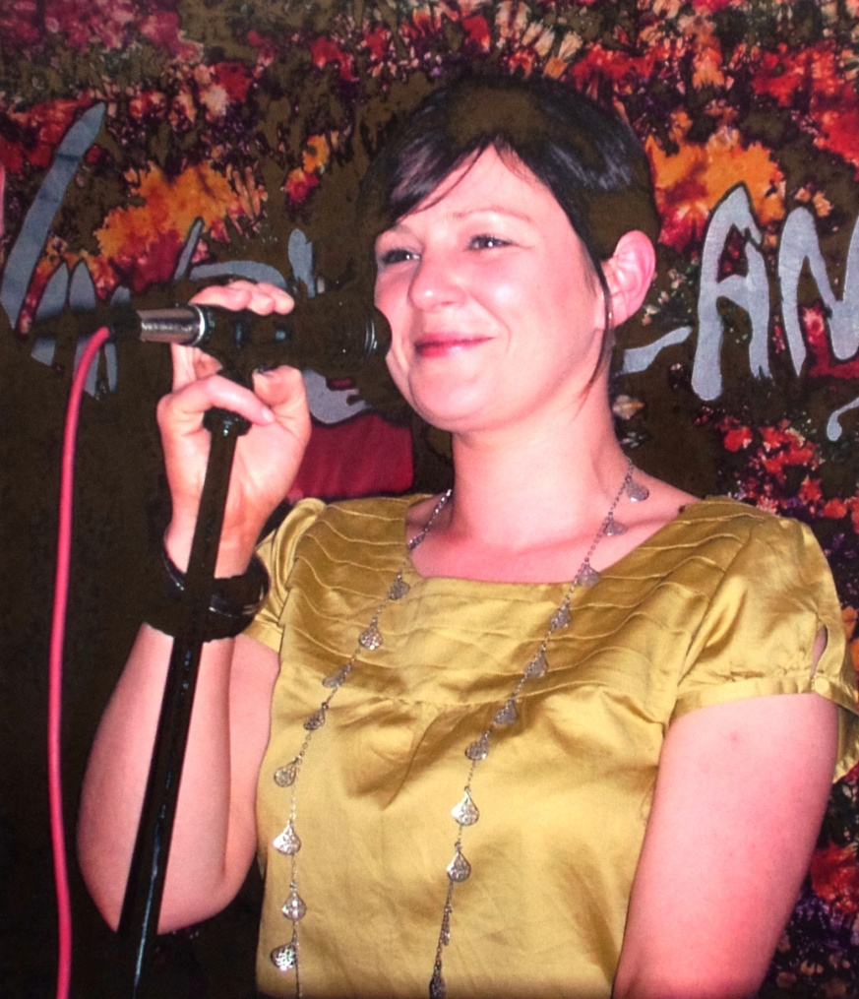
Tracy Fleming (nee Souter) was born in Aberdeen in 1976. With her parents Margaret and Graham Souter she moved around. until she settled in Gordon Crescent, Portsoy from 1983 – 1994.
It was a musical family. Her dad sang with “Malt and Barley” in the early 70s and her Granda (Douglas Souter) sang in the Portsoy church choir.
Tracy sang at school. Mrs Mair (from Banff) came to Portsoy Primary to teach singing. Tracy played the recorder at school and was a highland dancer at Anne McArthur’s School of Dance.
In terms of her musical career, Tracy sang with the award winning “Wonderland” and another 3-piece band called “Brando”. Wonderland are the current holders of the 2011/2012 VOWS Awards for wedding bands. This means their level of service and customer satisfaction is second to none. You'll get a flexible and talented band, able to play great covers of classic and current chart hits along with the ability to play and "call" the very best ceilidh and Scottish Country Dance tunes.
Although she has never written her own songs, Tracy has recorded CDs of other artists songs over the years. She features on three albums and copies will be in the Old Bakery soon!
When not expanding her delivery business Tracy helps out bands in the local area. She is keen to learn more about traditional Scottish music and to be involved with local musicians so as to find out what is going on where!
https://www.facebook.com/tracy.fleming

