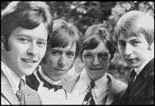
Johnny and the Copycats are a Rock & Roll band from the North East of Scotland.
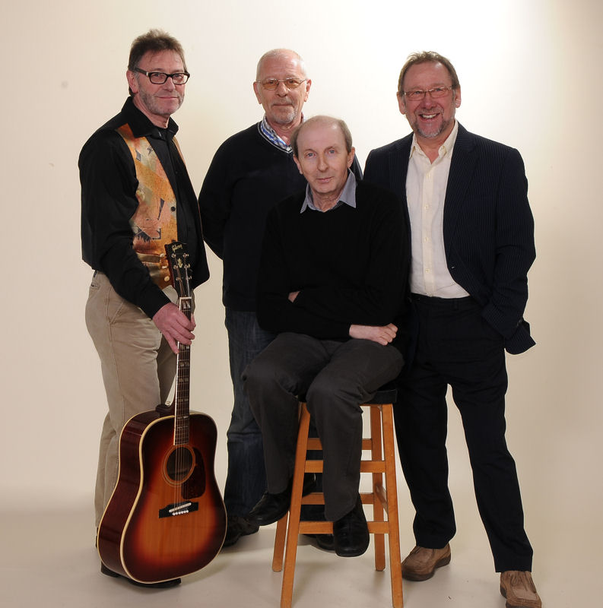
Johnny Stewart is a well-known business man who ran a successful butcher shop in Portsoy

The band has been together for over 50 years and has been on the same bill as many of the famous names from the 60s and 70s including the Beatles.
The original Johnny and the Copycats were Rob Lawson, Iain Lyon, John Stewart, and Billy Cameron.
Earlier this year the band spent a week at Foundry Music Lab in Motherwell recording a brand new five track ep. It is due for release in the middle of 2013. Watch their Facebook page for details
http://www.delgin.co.uk/cats/memorabilia.html
http://www.delgin.co.uk/cats/history.html
https://www.facebook.com/JohnnyandtheCopycats

